**EXPLORING MADRE DE CACAO *(GLIRICIDIA SEPIUM)* AS NATURAL HIGHLIGHTER INK**

A Qualitative Research Paper presented to

the Faculty of Senior High School Department

KING THOMAS LEARNING ACADEMY, INC.

Malubago, Sipocot, Camarines Sur.

In partial fulfilment of the requirements for the

subject Practical Research II

SCIENCE, TECHNOLOGY, ENGINEERING, AND MATHEMATICS

**Abaquita, Danica E.**

**Canal, Ashley Nicole O.**

**Encila, Virnes Jirah G.**

**Dullas, Kyle Sander C.**

**Magalona, Kyla Mae T.**

**Orfinada, Chelsea B.**

December 2024

**CERTIFICATE OF APPROVAL**

The research paper attached hereto, titled “**EXPLORING MADRE DE CACAO *(GLIRICIDIA SEPIUM)* AS NATURAL HIGHLIGHTER INK**” prepared and submitted by **DANICA E. ABAQUITA, ASHLEY NICOLE O. CANAL, VIRNES JIRAH G. ENCILA, KYLE SANDER C. DULLAS, KYLA T. MAGALONA, AND CHELSEA B. ORFINADA.** In partial fulfilment of the requirements for the subject Inquiries, Investigation, and Immersion, is hereby accepted and approved by the Board of Panel whose signature appears below.

**STEPHANIE T. HUERT**

Panel Member

**JESSA S. GABRIEL**

Panel Member

**ERLINDA N. DATINGINOO**

Panel Member

**RHAJEAN R. BUENAVENTURA**

Research Adviser

**MARY JOYCE N. RAMOS**

Assistant Principal – SHS Department

**ANGELI P. MORADA**

Academic Officer/Principal – SHS Department

**ACKNOWLEDGMENT**

The researchers would like to sincerely thank everyone who has helped us along the way and for their crucial support and efforts. The researchers' achievements have been greatly aided by their direction and support in their work. The researchers specifically want to express their gratitude to the following:

Above all, we give thanks and gratitude to God Almighty for his many blessings during the course of our research and its successful conclusion.

To **Mrs. Rhajean Buenaventura**, our research adviser, for her great assistance. Parenting, support, and supervision during our research project. We also want to thank her for sharing her knowledge, compassion, and empathy with us. Working and learning under her direction was an honor and privilege.

**Ms. Jessa Gabriel**, a science major who also served on the panel, offered us support as well as enlightening remarks and recommendations for the study paper's optimal outcome and for confirming our observation sheet. Our study paper would not have been feasible without their assistance.

**Ms. Erlinda Datinginoo**, an English major and one of the panelists provided us with thorough input on composition and language, which has been really helpful. Her commitment to English language proficiency is incredibly motivating, and her recommendations have significantly increased our study paper's coherence and clarity.

**Ms. Stephanie Huerte**, a Math major and one of the panelists. Her statistical knowledge was essential in determining the most appropriate statistical treatments and in interpreting the outcomes of our statistical measures. In addition to improving our comprehension, her advice on statistical analysis has guaranteed the accuracy and reliability of our results.

**Mrs. Angeli P. Morada**, a senior high school principal, for allowing us the opportunity to conduct our research among grade 12 STEM students.

We also like to express our gratitude to our responders, especially the **82 Grade 12 students** who voluntarily contributed their complete cooperation, which made the research project run smoothly. We also want to express our gratitude for sharing your time and expertise with us so that we could perform this study.

Additionally, we would want to express our gratitude to our classmates and friends for the thought-provoking conversations, the insights they provided into our product, and the overall enjoyment of our research project.

Last but not least, we would like to thank our parents for their unwavering support and careful consideration of the research study's expenses. Additionally, we appreciate their words of support while creating the research study.

We want to sincerely thank them for their unwavering support and careful evaluation of the research study's funding. We would like to express our sincere gratitude to the remaining panelists, whose opinions and ideas were crucial in helping us finish this thesis. Our future academic pursuits as well as current work have been influenced by your helpful critique. We are grateful for your assistance and for motivating us to strive for research excellence.

D.E.A

A.N.O.C

V.J.G.E

K.S.C.D

K.M.T.M

C.B.O

**EXPLORING MADRE DE CACAO (*Gliricidia sepium*) AS NATURAL HIGHLIGHTER INK**

2024

**ABSTRACT**

This study explored Madre de Cacao (Gliricidia sepium) extract as a natural highlighter ink by evaluating its effectiveness and acceptability in concentrations of 25%, 50%, and 75%. The study involved 82 Grade 12 students from King Thomas Learning Academy Inc., using random sampling and Slovin’s formula determined the sample size. Weighted means were employed to assess the effectiveness and acceptability of the highlighter ink, while One-way ANOVA was used to test for significant differences in the results. Findings revealed no significant differences in color, opacity, or smear-proof properties across the different concentrations. The 50% concentration was deemed the most effective due to its vibrant color and striking contrast, while the 75% concentration was favored for its smear resistance and paper adherence. Regarding acceptability, the 25% concentration was acceptable in packaging but had an unpleasant odor. The 50% concentration showed improvements in odor and packaging but was not acceptable in terms of shelf life. The 75% concentration had an unacceptable odor and shelf life. The study concluded that, although no significant differences were observed across concentrations, the 25% concentration is the most cost-effective option for natural highlighter ink, with adequate performance in color vibrancy and opacity. Further optimization is recommended, particularly to address odor and shelf life.

Keywords: *Madre de Cacao, highlighter ink, natural ink, concentration, acceptability, effectiveness*

|  |  |  |
| --- | --- | --- |
| **TABLE OF CONTENTS** | | |
| **Preliminaries** | | |
| Title Page | |  |
| Certificate of Approval | |  |
| Acknowledgment | |  |
| Abstract | |  |
| Table of Contents | |  |
| List of Tables | |  |
| List of Figures | |  |
| List of Appendices | |  |
| **Chapter I. Introduction** | | **01** |
| Statement of the Problem | | 03 |
| Objectives of the Study | | 03 |
| Scope and Limitations | | 04 |
| Significance of the Study | | 05 |
| **Chapter II. Review of Related Literature and Studies** | | **06** |
| Review of Related Literature | | 06 |
| Review of Related Studies | | 07 |
| Synthesis | | 09 |
| Theoretical Paradigm | | 12 |
| Conceptual Paradigm | | 15 |
| Definition of Terms | | 16 |
| Assumptions of the Study | | 17 |
| Hypothesis | | 17 |
| **Chapter III. Methodology** | | **18** |
| Research Design | | 18 |
| Research Setting | | 18 |
| Respondents | | 18 |
| Research Instrument | | 19 |
| Validity and Reliability | | 19 |
| Statistical Treatment | | 20 |
| Data Gathering Procedure | | 20 |
| **Chapter IV. Results and Discussion** | | 24 |
| Level of effectiveness with 25% concentration in terms of color. | | 24 |
| Level of effectiveness with 50% concentration in terms of color. | | 26 |
| Level of effectiveness with 75% concentration in terms of color. | | 27 |
| Effectiveness of Madre De Cacao as highlighter ink in different  concentration levels in terms of color. | | 28 |
| Level of effectiveness with 25% concentration in terms of opacity. | | 29 |
| Level of effectiveness with 50% concentration in terms of opacity. | | 31 |
| Level of effectiveness with 75% concentration in terms of opacity. | | 33 |
| Effectiveness of Madre De Cacao as highlighter ink in different  concentration levels in terms of opacity. | | 34 |
| Level of effectiveness with 25% concentration in terms of smear-proof. | | 35 |
| Level of effectiveness with 50% concentration in terms of smear-proof. | | 37 |
| Level of effectiveness with 75% concentration in terms of smear-proof. | | 38 |
| Effectiveness of Madre De Cacao as highlighter ink in different  concentration levels in terms of smear-proof. | | 39 |
| Effectiveness of Madre De Cacao as highlighter ink in 25%, 50% and 75% concentration in terms of color, opacity and smear-proof. | | 40 |
| Level of acceptability with 25% concentration in terms of odor. | | 41 |
| Level of acceptability with 50% concentration in terms of odor. | | 42 |
| Level of acceptability with 75% concentration in terms of odor. | | 43 |
| Acceptability of Madre De Cacao as highlighter ink in terms of odor. | | 44 |
| Level of acceptability with 25% concentration in terms of packaging. | | 46 |
| Level of acceptability with 50% concentration in terms of packaging. | | 48 |
| Level of acceptability with 75% concentration in terms of packaging. | | 50 |
| Acceptability of Madre De Cacao as highlighter ink in terms of packaging. | | 51 |
| Observation for 25% concentration | | 52 |
| Observation for 50% concentration | | 54 |
| Observation for 75% concentration | | 55 |
| Acceptability of Madre De Cacao as highlighter ink in terms of shelf-life. | | 57 |
| Acceptability of Madre De Cacao as highlighter ink in 25%, 50% and 75% concentration in terms of odor, packaging and shelf-life. | | 58 |
| The tabular representation of the difference between the level of effectiveness and level of acceptability of the highlighter ink among different concentrations. | | 58 |
| **Chapter V. Summary, Findings, and Conclusions** | | **60** | |
| **Problem 1.** What is level of effectiveness of Madre De Cacao among different concentrations in terms of? a. color b. opacity c. smear-proof | | 60 | |
| **Problem 2.** What is the level of acceptability of Madre De Cacao (G. sepium) as highlighter ink in terms of? a. odor b. packaging c. shelf-life | | 62 | |
| **Problem 3.** Is there any significant difference between the level of effectiveness and level of acceptability among different concentration? | | 64 | |
| **Appendices** | | Lxvi | |
| References | | Lxvii | |
| Approval sheet | | Lxx | |
| Observation sheet | | Lxxvii | |
| Statistical Computation | | Xcv | |
| Documentation | | Xcvii | |
| Curriculum Vitae | | C | |

|  |  |  |
| --- | --- | --- |
|  | **LIST OF TABLES** |  |
| **Table 1** | Materials used | 22 |
| **Table 2** | Level of effectiveness with 25% concentration in terms of color. | 24 |
| **Table 3** | Level of effectiveness with 50% concentration in terms of color. | 26 |
| **Table 4** | Level of effectiveness with 75% concentration in terms of color. | 27 |
| **Table 5** | Effectiveness of Madre De Cacao as highlighter ink in different  concentration levels in terms of color. | 28 |
| **Table 6** | Level of effectiveness with 25% concentration in terms of opacity. | 29 |
| **Table 7** | Level of effectiveness with 50% concentration in terms of opacity. | 31 |
| **Table 8** | Level of effectiveness with 75% concentration in terms of opacity. | 33 |
| **Table 9** | Effectiveness of Madre De Cacao as highlighter ink in different concentration levels in terms of opacity. | 34 |
| **Table 10** | Level of effectiveness with 25% concentration in terms of smear-proof. | 35 |
| **Table 11** | Level of effectiveness with 50% concentration in terms of smear-proof. | 37 |
| **Table 12** | Level of effectiveness with 75% concentration in terms of color. | 38 |
| **Table 13** | Effectiveness of Madre De Cacao as highlighter ink in different  concentration levels in terms of smear-proof. | 39 |
| **Table 14** | Effectiveness of Madre De Cacao as highlighter ink in 25%, 50% and 75% concentration in terms of color, opacity and smear-proof. | 40 |
| **Table 15** | Level of acceptability with 25% concentration in terms of odor. | 41 |
| **Table 16** | Level of acceptability with 50% concentration in terms of odor. | 42 |
| **Table 17** | Level of acceptability with 75% concentration in terms of odor. | 43 |
| **Table 18** | Acceptability of Madre De Cacao as highlighter ink in terms of odor. | 44 |
| **Table 19** | Level of acceptability with 25% concentration in terms of packaging. | 46 |
| **Table 20** | Level of acceptability with 50% concentration in terms of packaging. | 48 |
| **Table 21** | Level of acceptability with 75% concentration in terms of packaging. | 50 |
| **Table 22** | Acceptability of Madre De Cacao as highlighter ink in terms of packaging. | 51 |
| **Table 23** | Observation for 25% concentration | 52 |
| **Table 24** | Observation for 50% concentration | 54 |
| **Table 25** | Observation for 75% concentration | 55 |
| **Table 26** | Acceptability of Madre De Cacao as highlighter ink in terms of shelf-life. | 57 |
| **Table 27** | Acceptability of Madre De Cacao as highlighter ink in 25%, 50% and 75% concentration in terms of odor, packaging and shelf-life. | 58 |
| **Table 28** | The tabular representation of the difference between the level of effectiveness and level of acceptability of the highlighter ink among different concentrations. | 58 |

|  |  |  |
| --- | --- | --- |
|  | **LIST OF FIGURES** |  |
| **Figure 1** | Theoretical Framework | 11 |
| **Figures 2** | Conceptual Framework | 14 |

**CHAPTER I**

**INTRODUCTION**

Highlighters have become an essential tool in the modern educational traditions, transforming the way we engage with text. From students cramming for exams and to professionals crafting their works. Highlighters offer a simple yet effective way to emphasize key information. In a time when environmental friendliness and sustainability are of the utmost importance, the search for natural alternatives in everyday products has become increasingly significant. One intriguing candidate in this search is the Madre de Cacao tree, known for its vibrant leaves and rich chemical properties. This exploration delved into the potential of Madre de Cacao as a highlighter ink, examined its natural extract as an ink for highlighter.

Madre de Cacao (G. sepium) is a remarkable tree that thrives in tropical regions. Known for its rapid growth and resilience it plays a crucial role in sustainable agriculture. Recently, its vibrant leaves and tannin content garnered attention for their potential as natural inks, expanding it into more creative usage.

The potential of natural inks should be recognized by artists and do-it-yourself enthusiasts, who can source and create colors for small-scale projects. Since, synthetic chemicals used in many commercial highlighters pose environmental concerns, including their impact on ecosystems and human health. As Stephanie Chew (2021) stated “Natural inks are a cleaner, more sustainable option that could assist to keep toxic chemicals away from the environment and may even bring about deeper appreciation and connection with nature”. Part of this study’s objectives is also to demonstrate the great potential of the plant as an alternative highlighter pen considering the fact there are numerous health dangers and economic issues resulting from the use of commercial highlighter ink. The production of synthetic inks often involves volatile organic compounds (VOCs) that contribute to air pollution and can be harmful during manufacturing and usage (Hongzhuan, 2012).

The main purpose of this study was to create a natural ink from Madre De Cacao extract. Creating an eco-friendly highlighter that reduce our reliance on harmful chemicals and also helped reduce environmental impacts. Thus, through this investigation, the potential of Madre de Cacao as a natural ingredient for highlighter ink will be critically examined, with an emphasis on both its environmental benefits and its practical applications in everyday life.

**Statement of the Problem**

This study aimed to produce a natural highlighter ink made of Madre De Cacao (*G. Sepium*). Specifically, it sought to answer the following questions:

1. What is the level of effectiveness of Madre De Cacao (*G. sepium*) among different concentrations in terms of?

1. Color
2. Opacity
3. Smear-proof

2. What is the level of acceptability of Madre De Cacao (*G. sepium*) as highlighter ink in terms of?

1. Odor
2. Packaging
3. Shelf life

3. Is there any significant difference between the level of effectiveness and level of acceptability of the produced highlighter ink among different concentrations?

**Objectives of the Study**

The following objectives guided the study:

1. Determine the level of effectiveness of Madre De Cacao (*G. sepium*) among different concentrations in terms of?

1. Color
2. Opacity
3. Smear-proof

2. Identify the level of acceptability of Madre De Cacao (*G. sepium*) as highlighter ink in terms of?

1. Odor
2. Packaging
3. Shelf life

3. Evaluate if there is significant difference between the level of effectiveness and level of acceptability of the produced highlighter ink among different concentrations?

**Scope and Limitations**

The scope of this study was to create highlighter ink with Madre De Cacao. With the use of the extract from it a natural highlighter ink will be made. The developed product has been subjected to evaluation through testing, with the selected 82 Grade 12 students of King Thomas Learning Academy Inc. Slovin’s formula was used to get the sample size needed for this study.

The limitation of this study was it only focuses effectiveness and acceptability of the highlighter ink in terms of various qualities. For processing and manufacturing Madre De Cacao, the researchers used simple and low-cost processes such as grinding, combining, and packaging. The general purpose of this study was to determine the effectiveness and acceptability of the produced natural highlighter ink.

**Significance of the Study**

This study Exploring Madre De Cacao (*G. sepium*) as a natural highlighter ink was made to give important information and knowledge needed by the following:

**Students.** This study can be used as a basis for further research and this can provide new information in the production of highlighter pens made from organic sources. To add, they can use this for their academics especially when reviewing.

**Product Manufacturers.** This will be a valuable resource for them to create more products using natural materials.

**Teachers.** This study will benefit the teachers as highlighters are also one of their teaching materials.

**Future Researchers.** The findings of this study will benefit the researchers as this will serve as a valuable reference, providing information, sources and research materials for their own investigations.

**CHAPTER II**

**REVIEW OF RELATED LITERATURE AND STUDIES**

This paper introduced and presented a review of related literature and studies bearing upon the present pursuit of knowledge. The clear understanding and ideas procured from this review provided the researchers with useful and worthy insight to support the study.

**Review of Related Literature**

This chapter presented and discussed the reviewed literature that was closely related to the present research. It also presented the related literature, related studies, and synthesis. Furthermore, this provided a concise overview of the research and literature, both domestic and international that is relevant to these studies.

Nishimura et al. (2015) stated that enhancing academic performance is one of the most crucial learning goals for senior high school pupils. Every subject has a variety of problem types, and it was crucial to identify the main ideas and phrases in both questions and sentences in every circumstance. Information on phrases and questions should be arranged to make it easier to discover these keywords and essential elements, which can improve both cognitive and attentional capacity. Students use a variety of writing supplies, but highlighters are particularly popular because they are used for marking and can help organize information. This can improve students' academic performance through both the visual effects and the marking process.

As Segedie, L. (2017) stated that while organic products are celebrated for being free from synthetic chemicals and preservatives, these same qualities make them more vulnerable to spoilage and decomposition. Without artificial additives or heavy processing, organic foods are naturally more perishable, requiring more careful handling and faster consumption. While this is often seen as a trade-off for the higher quality and nutritional benefits of organic produce, it also means that consumers must plan to consume these products sooner, use proper storage methods, and be mindful of their limited shelf life.

Andrew Hurley (2018) Organic pigments are typically lightweight colors, which makes them ideal for a variety of applications. These pigments are made up of carbon atoms that form strong, stable chemical bonds, contributing to their durability and longevity. They are commonly found in nature, such as in animals and plants, as well as in synthetic forms created through organic chemistry. Due to their chemical composition, organic pigments often have vibrant, rich hues and are widely used in industries ranging from art and design to textiles and food.

According to Jyotsna (2023) the world of natural colors, plants stand out as a vibrant canvas ready to be explored. The process of extracting dyes and pigments from plants offers an intriguing glimpse into the complex chemistry that nature uses to create its own masterpiece. Plant pigments are the colorful compounds that give plants their wide range of hues. These pigments are essential for several important physiological functions in plants.

According to Pent, M. (2023) that a highlighter is an effective note-taking tool students use to highlight and emphasize important information in texts and notes. Since they help students learn and retain knowledge and visually organized and clarify notes, highlighters are a component of many students’ study habits.

**Review of Related Studies**

The study of Zhu Ji (2017) stated that different advantageous properties can be attained by using organic materials in highlighter pen inks. As an example, eco-friendly highlighter ink has been created using inorganic substances rather than the usual fluorescent materials, guaranteeing safety and environmental sustainability.

According to the study of De Leon et al. (2021) indicating that Madre De Cacao produces a strong, pungent odour from its leaves, which serves as a natural defence against pests and insects. The odour, caused by volatile oils, repels herbivores and helps protect the plant from damage. Despite its overpowering smell, it is not harmful to humans and does not cause adverse reactions. The tree is often used in agriculture as a natural insect repellent, making it beneficial in controlling pests without the need for synthetic pesticides.

According to the study of Liu et al. (2021) Numerous artificial highlighter inks contain dangerous substances like synthetic phenolic antioxidants and photo initiator, which have been found in printed paper products like magazines and food packaging materials. These substances may result in skin contact and possible health hazards, but current research indicates that the levels of exposure are quite low.

A study by Nagrale et al. (2022) demonstrated that that natural ink derived from organic sources share common properties with commercial inks and that ink derived from organic sources can be used commercially. The natural inks were also environmentally friendly, chemical-free, and biodegradable. These results further support the viability of organic highlighter pen inks as a sustainable and eco-friendly alternative to commercial highlighter pens.

The study of Castillo et al. (2024) recommended that further investigation of using natural inks derived from organic sources is needed for more development of ecologically friendly and sustainable production methods. Their study opened a possibility of utilizing organic materials as alternatives to traditional highlighter pen inks, contributing to environmentally conscious practices in the stationary industry.

**Synthesis**

This review showed the similarities, differences, and uniqueness of some related research about exploring Madre De Cacao (*G. sepium*) as natural highlighter ink. These several studies and literature helped the researchers and readers to further understand the study.

Nishimura et al. (2015) emphasized that improving academic performance was essential for senior high school students. Identifying key ideas and phrases in questions and sentences is crucial for organizing information, which enhances cognitive abilities and attention. Highlighters are commonly used by students to mark important content, helping to visually organize and emphasize key information, ultimately improving academic performance.

Castillo et al.(2024) stated that utilizing natural inks derived from organic sources in sustainable and eco-conscious production techniques. This study indicates the potential of using organic substances in place of conventional highlighter pen inks, advocating for environmentally responsible practices within the stationery sector. This is related to the present study due to the involvement of natural/organic ink for highlighter.

The study of Liu et al.(2021) stated that many artificial highlighter inks contain harmful substances such as synthetic phenolic antioxidants and photoinitiators. These substances have been discovered in printed paper items like magazines and food packaging materials. While there is a risk of skin contact and potential health hazards, recent studies show that the exposure levels are relatively low. This is different to the present study due to this study only focuses on the risk of potential health hazard that can cause to the user of the artificial highlighter inks.

The unique aspect of this study was that it investigated and created a substitute material, the Madre De Cacao (*G. sepium*) as a natural highlighter ink. The goal of this study is to determine the effectiveness in terms of colour, opacity and smear-proof and acceptability in terms of odor, packaging, and shelf-life.

Natural Product Theory

(Lavoiser, 1789)

Sustainable Development Theory

(Shakir Hanna, S. H., Cesaretti, G. P., 2019)

Color Theory

(Isaac Newton)

**EXPLORING MADRE DE CACAO (*Gliricidia Sepium*) AS NATURAL HIGHLIGHTER INK**

***Figure 1. Theoretical Framework***

**Theoretical Paradigm**

This section holds the theories that interconnect with the study:

**SUSTAINABLE DEVELOPMENT THEORY (Shakir Hanna, S. H., Cesaretti, G. P., 2019).** The theory of sustainable development is that humankind must preserve the natural world by ensuring that its resources are used wisely and preserved for future generations. This would prevent the planet from being destroyed as a result of human abuse while humans live there and enjoy its resources. It supports the responsible use of natural resources, promoting economic, environmental, and social sustainability. This theory is relevant to our research since the use of Madre Cacao as an ink source complies with sustainable development concepts, which advocate for the substitution of natural and renewable resources for synthetic ones.

**NATURAL PRODUCT THEORY (Lavoisier, 1789).** A natural product is a compound that occurs naturally in nature and is created by a living organism. It includes all materials created by living things. Natural products can also be created chemically, and because they provide difficult synthetic targets, they have been essential to the growth of organic chemistry. Natural product chemistry is concerned with the methods of extraction, and possible uses of materials that come from living things including plants, animals, and microorganisms. This realates to our study because the development of Madre Cacao as a highlighter ink requires an understanding of pigment extraction, the connection between color and chemical structure, and the durability of these compounds in various light and environmental circumstances.

**COLOR THEORY (Isaac Newton).** The Color theory is a historical knowledge that describes how colors behave, specifically in terms of color mixing, harmony, contrast, schemes, and symbolism. It also emphasizes the interactions, perceptions, and manipulations of color to achieve various effects. It enables us to comprehend the reasons behind the pleasing combinations of colors and how light influences our perception of them. It is relevant to our research on Madre Cacao as a source of highlighter ink since it involves learning how the plant’s natural pigments can produce particular colors, how to adjust these colors, and how these colors react to light and the human eye.

**OUTPUT**

SOP 1. All the concentrations was concluded as effective. However 75% concentration shows the best effectiveness in terms of color, and smear-proof and as for opacity it was the highlighter with 50% concentration.

SOP 2. The 50% concentration stands out the most acceptable out of the other concentrations since it is labelled as acceptable in terms of odor and packaging although not acceptable in terms of shelf-life.

SOP3. The analysis of the variance between the level of effectiveness and level of acceptability of the produced ink revealed no significant difference.

**PROCESS**

The researchers will perform various ways in gathering data this includes:

1. Gathering of materials.
2. Formulation of the highlighter.
3. Data Gathering
4. Quantitative Analysis
5. Findings, Conclusion and Recommendation

**INPUT**

1. The level of effectiveness of Madre De Cacao as highlighter ink among different concentrations in terms of color, opacity and smear-proof.
2. The level of acceptability of Madre De Cacaco (*G. sepium*)in terms of odor, packaging and shelf-life.
3. The significant difference between the level of effectiveness and level acceptability of the produced highlighter ink

Feedback

***Figure 2. Conceptual Framework***

**Conceptual Paradigm**

**INPUT.** The study showed different formulation affect the efficacy of organic inks, identified the best formulations methods, maximum effectiveness, acceptability, and examined the difference between the overall performances.

**PROCESS.** The first step in this process involved collecting all necessary materials and ingredients. Gathering enough Madre De Cacao leaves for the study. In addition with the leaves, suitable solvents such as water will be used to mix with the extract, the juice (extract) of the Madre De Cacao leaves. Equally important is ensuring that the appropriate materials such as weighing scale, gloves, refillable highlighter pen, mortar and pestle are prepared. Finally, tools for documentation, whether notebooks or digital devices, should be prepared to accurately record observations throughout the experiment. With all the materials prepared the next step is to conduct the experiment. This began with the gathered Madre De Cacao leaves needed, where the Madre De Cacao was grinded with the chosen solvent using the mortar and pestle. After grinding, the mixture is strained to remove not needed particles. Once the extract is prepared, it is poured inside the refillable highlighter.

As for gathering data, this begins with creating structured questionnaires aimed at assessing how well the highlighter performed, focusing on aspects such as color, opacity, smear-proof, odor and packaging. The survey questionnaires are then distributed to the selected respondents to ensure a diverse range of opinions. Observation about the shelf-life was also conducted by the researchers starting day 1 until day 10. After data is collected, it is compiled to be analyzed. Quantitative analysis followed the data collection phase, involving statistical examination to draw meaningful conclusions. Data from both observation and survey is entered into statistical treatment for analysis. Appropriate statistical tests, such as Weighted Mean and ANOVA, are applied to determine the significance of the results obtained from the observation and survey. The final step includes the findings, conclusion, and recommendations.

The findings presented the main data and outcomes discovered through research or analysis. The conclusion interprets the findings and discusses their significance in the context of the research question. The recommendations offered specific suggestions based on the findings and conclusions, and identified areas for further study or exploration to build on the current work.

**OUTPUT.** The study provided information on how effective and acceptable the highlighter ink was made from Madre De Cacao extract considering the different concentrations in terms of various indicators. It also provided suggestions that improved the overall performance of this highlighter ink

**Definition of Terms**

**Eco-friendly**. Is something that is not harmful to the environment. In this study it was used to distinguish the aspect of the highlighter ink.

***Gliricidia sepium* (Madre de cacao)**. Is a medium size leguminous tree belonging to the family Fabaceae. In this study it was used as the main ingredient of the highlighter ink.

**Highlighter.** It is also called a fluorescent pen, it is a type of writing device used to bring attention to sections of text by marking them with a vivid, translucent colour. In this study, it referred to the ink formulation created from natural sources, specifically Madre De Cacao extract.

**Opacity**. It is the degree to which something reduces the passage of light. In this study, it was referred to the level of transparency or coverage that the highlighter ink provided when applied to paper.

**Organic**. Produced or involving production without the use of chemical fertilizers, pesticides, or other artificial agents. In this study, it was emphasized the use of Madre Cacao leave’s extract produced highlighter ink in a natural and eco-friendly way.

**Assumption of the Study**

This study was premised in the following assumptions that:

1. The level of effectiveness and acceptability of Madre De Cacao (*G. sepsium*) may vary in the different concentrations.

1. This study assumed that the usage of Madre De Cacao (*G. sepsium*) as natural ink for highlighter will be effective and acceptable.

**Hypothesis**

**Ho**: There is no significant difference between the level of effectiveness and level of acceptability of Madre De Cacao (*G. sepsium*) as natural ink for highlighter.

**CHAPTER III**

**METHODOLOGY**

This chapter described the study's research design and instrument additionally, it contained the respondents, research setting, data-gathering procedure, statistical treatment, and more information and understanding.

**Research Design**

The study used a quantitative method in the form of an experimental design to collect data. Experimental research design employed a scientific approach and provided evidence for the study. The study involved evaluating the effectiveness and acceptability of the highlighter ink base on different concentrations.

**Research Setting**

The product experiment was conducted at one of the researcher’s locations at North Centro, Sipocot, Camarines Sur, that is 2.2 kilometers riding a tricycle from King Thomas Learning Academy, Inc. at Malubago, Sipocot, Camarines Sur. The data gathering was conducted at King Thomas Learning Academy, Inc. on the selected 82 Grade 12 students. Before the study was conducted, the researcher was assigned to give a letter of consent to the school institution where the specific respondents are studying.

**Respondents**

The primary respondents of this study were the selected 82 Grade 12 students of King Thomas learning Academy Inc. Who are willing enough to try, observe, and answer the given questions. The researchers ensured that the selected participants are adequate and will fulfill the qualifications needed. In this study, Slovin's was the most appropriate method for selecting the sample size of the participants, necessary to achieved a certain confidence interval when sampling a population. However, it does not require any further information of the student to guarantee the confidentiality of their answer.

**Research Instrument**

The primary method of the gathered information was through quantitative survey checklist and observation sheet. In this study, quantitative observations were used to gather data while performing the intended experiment. The researchers listed down all the materials as well as the overall observations based on the characteristics and result of the produced product. The observations based on the various views of the participants and researchers in considering the overall performance and characteristics of the natural ink for highlighter.

**Viability and Reliability**

To guarantee the validity of the study, the researchers informed the students as well as the teachers about the objective and importance of the study. The checklist was given to the selected Grade 12 students of King Thomas Learning Academy Inc. that are liable enough to provide all the data requested by the researchers. The researchers performed the mentioned survey and analysis assessed by the study's reliability and determined whether testing produced consistent results. In order to ensure the viability and reliability of the experimental observations, researchers provided a clear documentation in performing the experiment. In this way, a strong proof and evidence was presented to strengthen the reliability and validity of the study.

**Statistical Treatment**

To effectively analyzed and interpreted the gathered data, the researchers used the following statistical treatment:

**Weighted mean** was used to identify the level of effectiveness and level of acceptability of the produced highlighter ink in terms of color, opacity and smear-proof. Ranking technique was used to rank and evaluate the different indicators. To analyze if there is a significant difference between the level of effectiveness and level of acceptability **Analysis of Variance (ANOVA)** was used. Accordingly, the statistical analysis provided supportfor the conclusions and information collectedthroughout this investigation.

**Data Gathering Procedure**

In the data gathering procedure, the researchers began in collecting all necessary materials for the experiment. These materials included the madre de cacao leaves, a weighing scale, a plastic bag, a mortar and pestle, clean cloth for squeezing the extract, measuring cups, and refillable highlighter pens. The madre de cacao was the primary ingredient used in the extraction process, and its preparation was carried out with the right to ensure accurate results. The first step involved was the use of a weighing scale and madre de cacao was to prepare it for the measurement. The researchers used a weighing scale to obtain the exact measurements of the madre de cacao that is required for each concentration (25g, 50g, and 75g). Once each amount was weighed, the madre de cacao was transferred into separate plastic bags, each clearly labeled with the respective weight (25g, 50g, and 75g) to maintain organization. The next step involved placing the measured madre de cacao in a mortar and pestle. The plant material was then crushed thoroughly to break it down and facilitate the extraction process. The purpose of this crushing was to release the madre de cacao and make it easier to obtain the extract. The researchers ensured that the crushing process was done uniformly for each concentration to maintain consistency. After crushing, the madre de cacao was placed in a clean cloth to squeeze out the extract. The researchers carefully applied pressure to the cloth to extract as much as possible from the crushed madre de cacao. The extracted liquid was collected into separate measuring cups for each concentration. To obtain an organized extraction process, the researchers added exactly one tablespoon of water to each extract to aid in the mixing process and ensure the consistency of the product across all concentrations. Once the extracts were prepared, the researchers proceeded to transfer them into the refillable highlighter pens. Each pen was filled with the extract corresponding to a specific concentration (25%, 50%, or 75%). The researchers ensured that the correct amount of extract was added to each pen ensuring that the varying concentrations were accurately presented. The pens were then sealed and labeled according to their respective concentrations for future identification and use during the experiment. In gathering data the researchers prepared a well-structured checklist questionnaire that was conducted at King Thomas Learning Academy Inc., with 82 selected Grade 12 students as participants. These students will be selected through random sampling. The researchers personally distributed the survey questionnaires to each selected student. Prior to distribution, the researchers obtained approval from their thesis adviser for the survey instrument to ensure its validity and relevance to the research objectives. Each participant will be given a checklist questionnaire, which they will fill out individually. The researchers provide clarification if needed but ensure that the responses are completed independently by the participants. Upon completion of the questionnaires, the researchers will collect the surveys one by one. All responses that were used were gathered and stored securely to maintain confidentiality and integrity of the data. After collecting the completed questionnaire, the researchers input the data into a database for analysis. The data was organized and encoded for easier processing. Statistical Treatment was applied to the data to determine any significant findings relevant to study. The researchers used appropriate statistical tools and software to analyze the data and the collected conclusions from the survey results.

**Materials**

**Table 1. The following are the materials or ingredients with its quantities and uses that the researchers will be using in their study:**

|  |  |  |
| --- | --- | --- |
| **Materials/Ingredients** | **Quantity** | **Use/s** |
| **Weighing scale** | 1 piece | This was used to measure the ingredients needed. |
| **Measuring Cups** | 1 piece | This where we mix the ingredients needed for the highlighter. |
| **Gloves** | 6 pairs | This was used to protect and prevent unwanted particles in the hands. |
| **Madre De Cacao leaves** | 150 grams | This was used as the main ingredient for the highlighter. |
| **Refillable Highlighter Pen** | 3 pieces | Where the produced ink was put. |
| **Water** | 3 tablespoon | This is the solvent that was used. |
| **Clean cloth** | 1 piece | This was used to squeeze the main ingredient which is the Madre De Cacao to get the extract. |
| **Mortal and Pestle** | 1 piece | This was used to smash the Madre De Cacao. |
| **Plastic Bag** | 3 pieces | This was used to organized the different measurement of the madre de cacao. |

**CHAPTER IV**

**RESULTS AND DISCUSSION**

This chapter presented the result and discussion based on the data gathered given by the respondents, as they examined utilization of Madre De Cacao extract as a natural highlighter ink. The gathered data is presented in tabular form in accordance with the interpretation and discussion of the result based on the statement of the problem.

**Table 2. *Level of effectiveness with 25% concentration in terms of color.***

|  |  |  |  |
| --- | --- | --- | --- |
| **Indicators** | **Weighted Mean** | **Rank** | **Interpretation** |
| 1. The highlighter ink has a vibrant color. | 2.30 | 7 | Disagree |
| 1. The highlighter ink achieved bright color. | 2.18 | 8 | Disagree |
| 1. The highlighter ink is eye-catching. | 2.46 | 6 | Disagree |
| 1. The highlighter ink color creates visually striking contrast with the surrounding text. | 2.56 | 5 | Agree |
| 1. The highlighter ink lacks vibrancy. | 2.91 | 3 | Agree |
| 1. The highlighter ink color is dull and unappealing. | 2.63 | 4 | Agree |
| 1. The ink color makes the text difficult to read. | 2.13 | 10 | Disagree |
| 1. The highlighter ink is light colored. | 3.23 | 1 | Agree |
| 1. The highlighter ink is pale and muted. | 3.07 | 2 | Agree |
| 1. The highlighter ink is painful to look at. | 2.16 | 9 | Disagree |
| **GENERAL WEIGHTED MEAN: 2.57 Agree** | | | |

LEGEND:

3.26 – 4.0 Strongly Agree

2.51 – 3.25 Agree

1.76 – 2.50 Disagree

1.0 – 1.75 Strongly Disagree

Table 2 presented a detailed assessment of highlighter ink at 25% concentration, focusing on how well the highlighter performed in terms of color. Seeing statement 8 ranked as the highest with 3.23 mean labeled agree indicating that the highlighter with 25% concentration is light colored. Followed by statement 9, ranked 2nd with 3.07 mean labeled agree stated that the highlighter is pale and muted. Statement 5 ranked 3rd with 2.91 mean labeled agree indicated that the highlighter lacks vibrancy. It is concluded that the highlighter ink with 25% concentration is light colored, pale, muted and lacks vibrancy. These findings were supported by Andrew Hurley (2018) who stated that organic inks or pigments tend to be light weight colored.

**Table 3. *Level of effectiveness with 50% concentration in terms of color.***

|  |  |  |  |
| --- | --- | --- | --- |
| **Indicators** | **Weighted Mean** | **Rank** | **Interpretation** |
| 1. The highlighter ink has a vibrant color. | 2.71 | 5 | Agree |
| 1. The highlighter ink achieved bright color. | 2.54 | 8 | Agree |
| 1. The highlighter ink is eye-catching. | 2.66 | 6 | Agree |
| 1. The highlighter ink color creates visually striking contrast with the surrounding text. | 2.72 | 4 | Agree |
| 1. The highlighter ink lacks vibrancy. | 2.73 | 3 | Agree |
| 1. The highlighter ink color is dull and unappealing. | 2.61 | 7 | Agree |
| 1. The ink color makes the text difficult to read. | 2.20 | 10 | Disagree |
| 1. The highlighter ink is light colored. | 3.05 | 1 | Agree |
| 1. The highlighter ink is pale and muted. | 2.90 | 2 | Agree |
| 1. The highlighter ink is painful to look at. | 2.35 | 9 | Disagree |
| **GENERAL WEIGHTED MEAN: 2.65 Agree** | | | |

LEGEND:

3.26 – 4.0 Strongly Agree

2.51 – 3.25 Agree

1.76 – 2.50 Disagree

1.0 – 1.75 Strongly Disagree

Table 3 presented a detailed assessment of highlighter ink at 50% concentration, focusing on how well the highlighter performed in terms of color. Seeing statement 8 with 3.05 mean labeled agree ranked as the highest, stated that the highlighter with 50% concentration is light colored. Statement 9 ranked 2nd with 2.90 mean labeled agree stated that the highlighter is pale and muted. While statement 5th and 3rd with 2.73 mean labeled agree indicated that the highlighter ink lacks vibrancy. It is concluded that the highlighter is light colored, pale, muted and lacks vibrancy. These were also supported by Andrew Huley (2018) who stated that pigments and inks from Organic materials are light weighted or light colored in other words.

**Table 4. *Level of effectiveness with 75% concentration in terms of color.***

|  |  |  |  |
| --- | --- | --- | --- |
| **Indicators** | **Weighted Mean** | **Rank** | **Interpretation** |
| 1. The highlighter ink has a vibrant color. | 2.98 | 1 | Agree |
| 1. The highlighter ink achieved bright color. | 2.84 | 3.5 | Agree |
| 1. The highlighter ink is eye-catching. | 2.84 | 3.5 | Agree |
| 1. The highlighter ink color creates visually striking contrast with the surrounding text. | 2.90 | 2 | Agree |
| 1. The highlighter ink lacks vibrancy. | 2.73 | 7 | Agree |
| 1. The highlighter ink color is dull and unappealing. | 2.70 | 8 | Agree |
| 1. The ink color makes the text difficult to read. | 2.32 | 10 | Disagree |
| 1. The highlighter ink is light colored. | 2.80 | 5 | Agree |
| 1. The highlighter ink is pale and muted. | 2.77 | 6 | Agree |
| 1. The highlighter ink is painful to look at. | 2.40 | 9 | Disagree |
| **GENERAL WEIGHTED MEAN: 2.73 Agree** | | | |

LEGEND:

3.26 – 4.0 Strongly Agree

2.51 – 3.25 Agree

1.76 – 2.50 Disagree

1.0 – 1.75 Strongly Disagree

Table 4 presented a detailed assessment of highlighter ink at 75% concentration, focusing on how well the highlighter performed in terms of color. Seeing statement 1 with 2.98 mean labeled agree ranked as the highest, indicating that the highlighter with 75% concentration has a vibrant color. Statement 4 ranked 2nd with 2.90 mean labeled agree indicated that the highlighter created visually striking contrast with the surrounding text. Lastly statements 2 and 3 with 2.84 mean labeled agree ranked as 3rd states that the ink achieved bright color and it is eye-catching. It is concluded that the highlighter had a vibrant color, created visually striking contrast, achieved bright color and is eye-catching. These findings were supported by Jyotsna (2023) who stated that plant pigments are vibrant compounds responsible for the diverse array of colors observed in the plant kingdom.

***Table 5. Effectiveness of Madre De Cacao as highlighter ink in different concentration levels in terms of color.***

|  |  |  |  |
| --- | --- | --- | --- |
| Concentration level | Mean | Rank | Interpretation |
| 25% | 2.57 | 3 | Agree |
| 50% | 2.65 | 2 | Agree |
| 75% | 2.78 | 1 | Agree |

LEGEND:

3.26 – 4.0 Strongly Agree

2.51 – 3.25 Agree

1.76 – 2.50 Disagree

1.0 – 1.75 Strongly Disagree

Table 5, as a result of the data gathered from the students in terms of color of the natural highlighter, it showed that the highlighter with a 25g concentration level had a mean of 2.57 and is labeled as agree. The highlighter with a 50g concentration level had a mean of 2.65 and is labeled as agree. Lastly, the highlighter with a 75g concentration level had a mean of 2.78 and is labeled as agree. As a result, from the survey conducted with the grade 12 students, the students considered the color of the highlighter ink with 25g concentration as agree, the highlighter with 50g concentration level as agree, and the highlighter with 75g concentration level as agree. At 75g, the mean score is the highest (2.78), indicating that at this concentration level, the ink is perceived as most effective in terms of color. This finding were also supported by Jyotsna (2018) who stated that plant pigments are colorful compounds that give a wide range of hues.

**Table 6. *Level of effectiveness with 25%concentration in terms of opacity.***

|  |  |  |  |
| --- | --- | --- | --- |
| **Indicators** | **Weighted Mean** | **Rank** | **Interpretation** |
| 1. When I use it in highlighting the text is still visible. | 3.34 | 1 | Strongly Agree |
| 1. The highlighter ink is too transparent to effectively highlight text. | 2.88 | 4 | Agree |
| 1. When I use it in highlighting the text is still readable. | 3.21 | 2 | Agree |
| 1. The highlighter ink partially covers the underlying text, making it difficult to read. | 2.24 | 10 | Disagree |
| 1. The highlighter ink does not cover the text. | 2.85 | 5 | Agree |
| 1. The highlighter ink is opaque and completely covers the underlying text. | 2.34 | 9 | Disagree |
| 1. The highlighter ink does not cover the text. | 2.84 | 6 | Agree |
| 1. The highlighter ink does not obscure the text behind. | 2.80 | 7 | Agree |
| 1. The highlighter ink allows visibility of the text underneath. | 2.99 | 3 | Agree |
| 1. The highlighter ink completely covers the underlying text, making it completely illegible. | 2.38 | 8 | Disagree |
| **GENERAL WEIGHTED MEAN: 2.79 Agree** | | | |

LEGEND:

3.26 – 4.0 Strongly Agree

2.51 – 3.25 Agree

1.76 – 2.50 Disagree

1.0 – 1.75 Strongly Disagree

Table 6 presented a detailed assessment of highlighter ink at 25% concentration, focusing on how well the highlighter performed in terms of opacity. Seeing statement 1 ranked as the highest with 3.34 mean the respondents strongly agreed that the highlighter with 25% concentration when highlighting the text was still visible. Statement 3 was ranked 2nd with 3.21 mean it indicated that the highlighter when used in highlighting the text was still readable. Statement 9, ranked 3rd with 2.99 mean it states that the highlighter ink allows visibility of the text underneath. It was concluded that the highlighter ink with 25% concentration when used in highlighting the text is still visible, readable and allowed visibility of the text underneath. These findings are supported by Pent, M. (2023) indicating that highlighters does emphasize or mark key information in your documents.

**Table 7. *Level of effectiveness with 50% concentration in terms of opacity.***

|  |  |  |  |
| --- | --- | --- | --- |
| **Indicators** | **Weighted Mean** | **Rank** | **Interpretation** |
| 1. When I use it in highlighting the text is still visible. | 3.34 | 1 | Strongly Agree |
| 1. The highlighter ink is too transparent to effectively highlight text. | 2.95 | 4 | Agree |
| 1. When I use it in highlighting the text is still readable. | 3.22 | 2 | Agree |
| 1. The highlighter ink partially covers the underlying text, making it difficult to read. | 2.34. | 10 | Disagree |
| 1. The highlighter ink does not cover the text. | 2.77 | 6 | Agree |
| 1. The highlighter ink is opaque and completely covers the underlying text. | 2.52 | 9 | Agree |
| 1. The highlighter ink does not cover the text. | 2.60 | 8 | Agree |
| 1. The highlighter ink does not obscure the text behind. | 2.84 | 5 | Agree |
| 1. The highlighter ink allows visibility of the text underneath. | 2.98 | 3 | Agree |
| 1. The highlighter ink completely covers the underlying text, making it completely illegible. | 2.65 | 7 | Agree |
| **GENERAL WEIGHTED MEAN: 2.82 Agree** | | | |

LEGEND:

3.26 – 4.0 Strongly Agree

2.51 – 3.25 Agree

1.76 – 2.50 Disagree

1.0 – 1.75 Strongly Disagree

Table 7 presented a detailed assessment of highlighter ink at 50% concentration, focusing on how well the highlighter performed in terms of opacity. Seeing statement 1 ranked as the highest with a weighted mean of 3.34, the highlighter with 50% concentration when used as a highlighter, the text was still visible. Statement 3 ranked 2nd with 3.22 mean it indicated that the highlighter when used in highlighting the text was still readable. Statement 9, ranked 3rd with 2.98 mean it stated that the highlighter ink allowed visibility of the text underneath. It was concluded that the highlighter ink with 50% concentration when used in highlighting the text was still visible, readable and allowed visibility of the text underneath. These findings are also supported by Pent, M. (2023) stating the sole purpose of highlighters is to mark or highlight important texts in your documents.

**Table 8. *Level of effectiveness with 75% concentration in terms of opacity.***

|  |  |  |  |
| --- | --- | --- | --- |
| **Indicators** | **Weighted Mean** | **Rank** | **Interpretation** |
| 1. When I use it in highlighting the text is still visible. | 3.12 | 1 | Agree |
| 1. The highlighter ink is too transparent to effectively highlight text. | 2.82 | 4 | Agree |
| 1. When I use it in highlighting the text is still readable. | 3.11 | 2 | Agree |
| 1. The highlighter ink partially covers the underlying text, making it difficult to read. | 2.45 | 10 | Disagree |
| 1. The highlighter ink does not cover the text. | 2.63 | 7.5 | Agree |
| 1. The highlighter ink is opaque and completely covers the underlying text. | 2.71 | 5 | Agree |
| 1. The highlighter ink does not cover the text. | 2.67 | 6 | Agree |
| 1. The highlighter ink does not obscure the text behind. | 2.63 | 7.5 | Agree |
| 1. The highlighter ink allows visibility of the text underneath. | 2.90 | 3 | Agree |
| 1. The highlighter ink completely covers the underlying text, making it completely illegible. | 2.60 | 9 | Agree |
| **GENERAL WEIGHTED MEAN: 2.76 Agree** | | | |

LEGEND:

3.26 – 4.0 Strongly Agree

2.51 – 3.25 Agree

1.76 – 2.50 Disagree

1.0 – 1.75 Strongly Disagree

Table 8 presented a detailed assessment of highlighter ink at 75% concentration, focusing on how well the highlighter performs in terms of opacity. Seeing statement 1 ranked as the highest with 3.12 mean the respondents strongly agreed that the highlighter with 75% concentration when highlighting the text was still visible. Statement 3 was ranked 2nd with 3.11 mean it indicated that the highlighter when used in highlighting the text was still readable. Statement 9, ranked 3rd with 2.90 mean it stated that the highlighter ink allowed visibility of the text underneath. It was concluded that the highlighter ink with 75% concentration when used in highlighting the text is still visible, readable and allows visibility of the text underneath. These findings are also supported by Pent, M. (2023) indicating that a highlighter is an effective note-taking tool students use to highlight and emphasize important information in texts and notes.

**Table 9. *Effectiveness of Madre De Cacao as highlighter ink in different concentration levels in terms of opacity.***

|  |  |  |  |
| --- | --- | --- | --- |
| Concentration level | Mean | Rank | Interpretation |
| 25% | 2.78 | 2 | Agree |
| 50% | 2.82 | 1 | Agree |
| 75% | 2.76 | 3 | Agree |

LEGEND:

3.26 – 4.0 Strongly Agree

2.51 – 3.25 Agree

1.76 – 2.50 Disagree

1.0 – 1.75 Strongly Disagree

Table 9, as a result of the data gathered from the students in terms of opacity of the natural highlighter, it showed that the highlighter with a 25g concentration level had a mean of 2.78 and was labeled as agree. The highlighter with a 50g concentration level had a mean of 2.82 and was labeled as agreed. Lastly, the highlighter with a 75g concentration level had a mean of 2.76 and was labeled as agree. As a result, from the survey conducted with the grade 12 students, the students considered the opacity of the highlighter ink with 25g concentration as agree, the highlighter with 50g concentration level as agree, and the highlighter with 75g concentration level as agree. At 50g, the mean score is the highest (2.82), indicating that at this concentration level, the ink was perceived as most effective in terms of opacity.

**Table 10. *Level of effectiveness with 25% concentration in terms of Smear-proof.***

|  |  |  |  |
| --- | --- | --- | --- |
| **Indicators** | **Weighted Mean** | **Rank** | **Interpretation** |
| 1. The highlighter ink smears significantly when touched or rubbed shortly after application. | 2.77 | 4.5 | Agree |
| 1. The highlighter ink does not smudge. | 2.57 | 9.5 | Agree |
| 1. After applying the highlighter, it does not spread when touched. | 2.77 | 4.5 | Agree |
| 1. The highlighter ink smears when highlighted over printed text. | 2.78 | 3 | Agree |
| 1. The highlighter bleeds through when used. | 2.71 | 6 | Agree |
| 1. The highlighter ink adheres to the paper. | 2.88 | 1.5 | Agree |
| 1. The highlighter ink does not dry quickly enough to prevent smearing when applied to paper. | 2.88 | 1.5 | Agree |
| 1. The highlighter ink smudges easily. | 2.68 | 7 | Agree |
| 1. The highlighter ink resists smearing. | 2.57 | 9.5 | Agree |
| 1. The highlighter does not bleed through when used. | 2.63 | 8 | Agree |
| **GENERAL WEIGHTED MEAN: 2.72 Agree** | | | |

LEGEND:

3.26 – 4.0 Strongly Agree

2.51 – 3.25 Agree

1.76 – 2.50 Disagree

1.0 – 1.75 Strongly Disagree

Table 10 presented a detailed assessment of highlighter ink at 25% concentration, focusing on how well the highlighter performed in terms of smear-proof. Seeing statements 6 and 7 both ranked the highest with 2.88 mean showed that regarding 25% concentration the highlighter ink adheres to the paper but does not dry quickly. Followed by statement 4 ranked 3rd with 2.78 mean stated that the highlighter ink smears significantly when touched or rubbed shortly after application. It is concluded that considering 25% concentration the highlighter ink adheres to the paper, does not dry quickly and smears when touched.

**Table 11. *Level of effectiveness with 50% concentration in terms of Smear-proof.***

|  |  |  |  |
| --- | --- | --- | --- |
| **Indicators** | **Weighted Mean** | **Rank** | **Interpretation** |
| 1. The highlighter ink smears significantly when touched or rubbed shortly after application. | 2.76 | 3.5 | Agree |
| 1. The highlighter ink does not smudge. | 2.73 | 5 | Agree |
| 1. After applying the highlighter, it does not spread when touched. | 2.60 | 9 | Agree |
| 1. The highlighter ink smears when highlighted over printed text. | 2.76 | 3.5 | Agree |
| 1. The highlighter bleeds through when used. | 2.67 | 6.5 | Agree |
| 1. The highlighter ink adheres to the paper. | 2.85 | 2 | Agree |
| 1. The highlighter ink does not dry quickly enough to prevent smearing when applied to paper. | 2.95 | 1 | Agree |
| 1. The highlighter ink smudges easily. | 2.67 | 6.5 | Agree |
| 1. The highlighter ink resists smearing. | 2.51 | 10 | Agree |
| 1. The highlighter does not bleed through when used. | 2.66 | 8 | Agree |
| **GENERAL WEIGHTED MEAN: 2.72 Agree** | | | |

LEGEND:

3.26 – 4.0 Strongly Agree

2.51 – 3.25 Agree

1.76 – 2.50 Disagree

1.0 – 1.75 Strongly Disagree

Table 11 presented a detailed assessment of highlighter ink at 50% concentration, focused on how well the highlighter performed in terms of smear-proof. Seeing statement 7 ranked that highest with 2.95 mean it indicates that the highlighter with 50% concentration the ink does not dry quickly enough to prevent smearing when applied to paper. Statement 6 ranked the 2nd with 2.85 stated that the highlighter ink adheres to the paper. Statements 1 and 4 tied at 3rd with 2.76 mean indicated that the highlighter smears when used in highlighting and smears when touched or rubbed. It was concluded that regarding 50% concentration the highlighter ink adheres to the paper, does not dry quickly and smears when used and touched.

**Table 12. *Level of effectiveness with 75% concentration in terms of Smear-proof.***

|  |  |  |  |
| --- | --- | --- | --- |
| **Indicators** | **Weighted Mean** | **Rank** | **Interpretation** |
| 1. The highlighter ink smears significantly when touched or rubbed shortly after application. | 2.74 | 6 | Agree |
| 1. The highlighter ink does not smudge. | 2.87 | 2 | Agree |
| 1. After applying the highlighter, it does not spread when touched. | 2.73 | 7 | Agree |
| 1. The highlighter ink smear when highlighted over printed text. | 2.70 | 8 | Agree |
| 1. The highlighter bleed through when used. | 2.77 | 4 | Agree |
| 1. The highlighter ink adheres to the paper. | 3.02 | 1 | Agree |
| 1. The highlighter ink does not dry quickly enough to prevent smearing when applied to paper. | 2.82 | 3 | Agree |
| 1. The highlighter ink smudges easily. | 2.76 | 5 | Agree |
| 1. The highlighter ink resist smearing. | 2.67 | 9 | Agree |
| 1. The highlighter does not bleed through when used. | 2.63 | 10 | Agree |
| **GENERAL WEIGHTED MEAN: 2.77 Agree** | | | |

LEGEND:

3.26 – 4.0 Strongly Agree

2.51 – 3.25 Agree

1.76 – 2.50 Disagree

1.0 – 1.75 Strongly Disagree

Table 12 presented a detailed assessment of highlighter ink at 75% concentration, focusing on how well the highlighter performed in terms of smear-proof. Seeing statement 6 ranked as the highest with 3.02 stated that the highlighter with 75% concentration adheres to the paper. Statement 2 ranked as the 2nd with 2.87 mean indicated that the highlighter does not smudge. Followed by statement 7 ranked as 3rd stated that the highlighter ink does not dry quickly enough to prevent smearing when applied to paper. It was concluded that the highlighter with 75% concentration adheres to the paper, does not smudge and does not dry quickly enough.

***Table 13. Effectiveness of Madre De Cacao as highlighter ink in different concentration levels in terms of Smear-proof.***

|  |  |  |  |
| --- | --- | --- | --- |
| Concentration level | Mean | Rank | Interpretation |
| 25% | 2.72 | 2.5 | Agree |
| 50% | 2.72 | 2.5 | Agree |
| 75% | 2.77 | 1 | Agree |

LEGEND:

3.26 – 4.0 Strongly Agree

2.51 – 3.25 Agree

1.76 – 2.50 Disagree

1.0 – 1.75 Strongly Disagree

Table 13, as a result of the data gathered from the students in terms of smear-proof of the natural highlighter, it showed that the highlighter with a 25g concentration level has a mean of 2.72 and was labeled as agree. The highlighter with a 50g concentration level also has a mean of 2.72 and was labeled as agree. Lastly, the highlighter with a 75g concentration level has a mean of 2.77 and was labeled as agree. As a result, from the survey conducted with the grade 12 students, the students considered the smear-proof of the highlighter ink with 25g concentration as agree, the highlighter with 50g concentration level as agree, and the highlighter with 75g concentration level as agree. At 75g, the mean score is the highest (2.77), indicated that at this concentration level, the ink is perceived as most effective in terms of smear-proof.

***Table 14. Effectiveness of Madre De Cacao as highlighter ink in 25%, 50% and 75% concentration in terms of color, opacity and smear-proof.***

|  |  |  |  |
| --- | --- | --- | --- |
| Indicators | 25% | 50% | 75% |
| Color | 2.57 | 2.65 | 2.78 |
| Opacity | 2.78 | 2.82 | 2.76 |
| Smear-proof | 2.72 | 2.72 | 2.77 |

Table 14 presented the weighted mean of each concentration level considering its color, opacity and smear-proof. Based on the overall data gathered, it was seen that for 25% and 50% concentration the highlighter was effective in terms of color, opacity and smear-proof. As for 75% concentration, it was shown as the most notable result based on the gathered data since it showed good quality of color, flexing bright color and vibrancy, good opacity and showed smudge resistance compared to other concentrations.

**Table 15. *Level of acceptability with 25% in terms of odor.***

|  |  |  |  |
| --- | --- | --- | --- |
| **Indicators** | **Weighted Mean** | **Rank** | **Interpretation** |
| 1. The highlighter has a refreshing scent. | 2.20 | 9.5 | Disagree |
| 1. The highlighter’s odor is fresh and subtle. | 2.35 | 7.5 | Disagree |
| 1. The highlighter smells good and is not overpowering. | 2.20 | 9.5 | Disagree |
| 1. The highlighter has a soothing smell. | 2.35 | 7.5 | Disagree |
| 1. The highlighter’s smell is light and pleasant. | 2.40 | 5 | Disagree |
| 1. The highlighter has an irritating scent. | 2.55 | 5 | Agree |
| 1. The highlighter’s odor is unpleasant. | 2.59 | 3 | Agree |
| 1. The highlighter has an overpowering smell. | 2.57 | 4 | Agree |
| 1. The highlighter has a harsh smell. | 2.61 | 2 | Agree |
| 1. The highlighter’s smell is distracting. | 2.65 | 1 | Agree |
| **GENERAL WEIGHTED MEAN: 2.45 Disagree** | | | |

LEGEND:

3.26 – 4.0 Strongly Agree

2.51 – 3.25 Agree

1.76 – 2.50 Disagree

1.0 – 1.75 Strongly Disagree

Table 15 presented a detailed assessment of highlighter ink at 25% concentration, focusing on how acceptable the highlighter in terms of odor. Seeing statement 10 ranked the highest with 2.65 mean labeled as Agree, it indicated that the highlighter with 25% concentration smell’s distracting. Statements 1 and 3 both ranked at 2nd with 2.20 labeled as disagree, it stated that the highlighter does not have a refreshing scent, it does not smell good and it was overpowering. Statement 7 ranked 3rd with 2.59 mean labeled as agree, it indicated that the highlighter’s odor is unpleasant. It was concluded that the highlighter with 25% concentration smell is distracting, does not have a refreshing scent, doesn't smell good and overpowering and its odor is unpleasant.

**Table 16. *Level of acceptability with 50% concentration in terms of odor.***

|  |  |  |  |
| --- | --- | --- | --- |
| **Indicators** | **Weighted Mean** | **Rank** | **Interpretation** |
| 1. The highlighter has a refreshing scent. | 2.32 | 10 | Disagree |
| 1. The highlighter’s odor is fresh and subtle. | 2.38 | 9 | Disagree |
| 1. The highlighter smells good and is not overpowering. | 2.39 | 8 | Disagree |
| 1. The highlighter has a soothing smell. | 2.43 | 6 | Disagree |
| 1. The highlighter’s smell is light and pleasant. | 2.40 | 7 | Disagree |
| 1. The highlighter has an irritating scent. | 2.60 | 5 | Agree |
| 1. The highlighter’s odor is unpleasant. | 2.62 | 3.5 | Agree |
| 1. The highlighter has an overpowering smell. | 2.62 | 3.5 | Agree |
| 1. The highlighter has a harsh smell. | 2.66 | 2 | Agree |
| 1. The highlighter’s smell is distracting. | 2.71 | 1 | Agree |
| **GENERAL WEIGHTED MEAN: 2.51 Agree** | | | |

LEGEND:

3.26 – 4.0 Strongly Agree

2.51 – 3.25 Agree

1.76 – 2.50 Disagree

1.0 – 1.75 Strongly Disagree

Table 16 presented a detailed assessment of highlighter ink at 50% concentration, focusing on how acceptable the highlighter in terms of odor. Seeing statement 10 ranked the highest with 2.71 mean labeled as agree, it indicated that in 50% concentration the highlighter smells distracting. Statement 9 ranked as the 2nd with 2.66 mean labeled agree stated that the highlighter has a harsh smell. Statements 7 and 8 tied at ranked 3 with 2.62 mean labeled agree stated that the highlighters odor was unpleasant and has an overpowering smell. It was concluded that the highlighter with 50% concentration smells distracting, has a harsh smell, its odor was unpleasant and has an overpowering smell.

**Table 17. *Level of acceptability with 75% concentration in terms of odor.***

|  |  |  |  |
| --- | --- | --- | --- |
| **Indicators** | **Weighted Mean** | **Rank** | **Interpretation** |
| 1. The highlighter has a refreshing scent. | 2.10 | 10 | Disagree |
| 1. The highlighter’s odor is fresh and subtle. | 2.20 | 8 | Disagree |
| 1. The highlighter smells good and is not overpowering. | 2.18 | 9 | Disagree |
| 1. The highlighter has a soothing smell. | 2.27 | 7 | Disagree |
| 1. The highlighter’s smell is light and pleasant. | 2.40 | 5 | Disagree |
| 1. The highlighter has an irritating scent. | 2.73 | 2 | Agree |
| 1. The highlighter’s odor is unpleasant. | 2.70 | 4 | Agree |
| 1. The highlighter has an overpowering smell. | 2.74 | 1 | Agree |
| 1. The highlighter has a harsh smell. | 2.34 | 6 | Disagree |
| 1. The highlighter’s smell is distracting. | 2.72 | 3 | Agree |
| **GENERAL WEIGHTED MEAN: 2.47 Disagree** | | | |

LEGEND:

3.26 – 4.0 Strongly Agree

2.51 – 3.25 Agree

1.76 – 2.50 Disagree

1.0 – 1.75 Strongly Disagree

Table 17 presented a detailed assessment of highlighter ink at 75% concentration, focusing on how acceptable the highlighter in terms of odor. The result showed that the highest-ranked indicator is statement 8 with a 2.74 mean labeled as agree stated that the highlighter has an overpowering smell. Statement 6 second ranked with 2.73 mean labeled as agree stated that the highlighter has an irritating scent. Statement 10 ranked third with 2.72 mean labeled as agree indicated that the highlighter’s smell was distracting. Overall the results concluded that the highlighter ink with 75% concentration has distracting overpowering irritating scent.

It was concluded that most of the concentrations resulted on having unpleasant, irritating, distracting and overpowering smell. This findings was supported by the study of De Leon et al. (2021) indicating that Madre De Cacao leaves has a distinct and overpowering smell that attracts attention despite this it is not harmful for humans.

***Table 18. Acceptability of Madre De Cacao as highlighter ink in terms of odor.***

|  |  |  |  |
| --- | --- | --- | --- |
| Concentration level | Mean | Rank | Level of Effectiveness |
| 25% | 2.45 | 3 | Disagree |
| 50% | 2.52 | 1 | Agree |
| 75% | 2.47 | 2 | Disagree |

LEGEND:

3.26 – 4.0 Strongly Agree

2.51 – 3.25 Agree

1.76 – 2.50 Disagree

1.0 – 1.75 Strongly Disagree

Table 18, as a result of the data gathered from the students in terms of odor of the natural highlighter, it showed that the highlighter with a 25g concentration level had a mean of 2.45 and was labeled as disagree. The highlighter with a 50g concentration level had a mean of 2.52 and was labeled as agree. Lastly, the highlighter with a 75g concentration level had a mean of 2.47 and was labeled as disagree. As a result, from the survey conducted with the grade 12 students, the students considered the odor of the highlighter with 25g concentration as disagree, the highlighter with 50g concentration level as agree, and the highlighter with 75g concentration level as disagree. At 50g, the mean score is the highest (2.52), indicating that at this concentration level, the highlighter was perceived as most acceptable in terms of odor.

**Table 19. *Level of acceptability with 25% concentration in terms of packaging.***

|  |  |  |  |
| --- | --- | --- | --- |
| **Indicators** | **Weighted Mean** | **Rank** | **Interpretation** |
| 1. The highlighter’s packaging has simple and minimalist design. | 3 | 4 | Agree |
| 1. The highlighter’s packaging is secure and leak-proof. | 2.93 | 5 | Agree |
| 1. The highlighter’s package is easy to handle and to use. | 3.12 | 3 | Agree |
| 1. The highlighter’s packaging is transparent and easy to monitor ink level. | 3.24 | 1 | Agree |
| 1. The highlighter’s packaging is good for refilling. | 3.16 | 2 | Agree |
| 1. The highlighter’s packaging looks vulnerable to cracking or breaking. | 2.54 | 10 | Agree |
| 1. The highlighter’s packaging is potential in leakage if not sealed properly. | 2.79 | 7 | Agree |
| 1. The highlighter’s packaging has small cap that could be easily lost. | 2.71 | 8 | Agree |
| 1. The highlighter’s packaging is to plain and lack in design. | 2.83 | 6 | Agree |
| 1. The highlighter’s packaging is unattractive and unappealing. | 2.64 | 9 | Agree |
| **GENERAL WEIGHTED MEAN: 2.90 Agree** | | | |

LEGEND:

3.26 – 4.0 Strongly Agree

2.51 – 3.25 Agree

1.76 – 2.50 Disagree

1.0 – 1.75 Strongly Disagree

Table 19 presented a detailed assessment of highlighter ink at 25% concentration, focusing on how acceptable the highlighter is in terms of packaging. Statement 4 ranked as the highest with 3.24 mean labeled as agree indicated that the highlighter’s packaging is transparent and easy to monitor ink level. Statement 5 second ranked with 3.16 mean labeled agree stated that the highlighters packaging was good for refilling. Statement 3 third ranked with 3.12 mean labeled agree stated that the highlighter’s packaging is easy to handle and use. It was concluded that in terms of packaging with 25% concentration most respondents agreed that it was easy to monitor ink level, good for refilling and it was easy to handle and use.

**Table 20. *Level of acceptability with 50% concentration in terms of packaging.***

|  |  |  |  |
| --- | --- | --- | --- |
| **Indicators** | **Weighted Mean** | **Rank** | **Interpretation** |
| 1. The highlighter’s packaging has simple and minimalist design. | 2.99 | 5 | Agree |
| 1. The highlighter’s packaging is secure and leak-proof. | 3.01 | 4 | Agree |
| 1. The highlighter’s package is easy to handle and to use. | 3.15 | 2 | Agree |
| 1. The highlighter’s packaging is transparent and easy to monitor ink level. | 3.26 | 1 | Strongly Agree |
| 1. The highlighter’s packaging is good for refilling. | 3.07 | 3 | Agree |
| 1. The highlighter’s packaging looks vulnerable to cracking or breaking. | 2.68 | 8.5 | Agree |
| 1. The highlighter’s packaging is potential in leakage if not sealed properly. | 2.79 | 7 | Agree |
| 1. The highlighter’s packaging has small cap that could be easily lost. | 2.68 | 8.5 | Agree |
| 1. The highlighter’s packaging is to plain and lack in design. | 2.83 | 6 | Agree |
| 1. The highlighter’s packaging is unattractive and unappealing. | 2.62 | 10 | Agree |
| **GENERAL WEIGHTED MEAN: 2.91 Agree** | | | |

LEGEND:

3.26 – 4.0 Strongly Agree

2.51 – 3.25 Agree

1.76 – 2.50 Disagree

1.0 – 1.75 Strongly Disagree

Table 20 presented a detailed assessment of highlighter ink at 50% concentration, focusing on how acceptable the highlighter is in terms of packaging. Statement 4 ranked the highest with 3.26 mean labeled strongly agree stated that most of the respondents agreed that highlighter’s packaging was transparent and easy to monitor ink level. Statement 3 second ranked with 3.15 mean labeled agree indicated that the highlighters packaging was easy to handle and use. Statement 5 ranked third with 3.07 mean labeled agree stated that the highlighters packaging was good for refilling. Overall, the results showed that the highlighter in terms of packaging, it was easy to handle and use, transparent and easy to monitor ink level and good for refilling.

**Table 21. *Level of acceptability with 75% concentration in terms of packaging.***

|  |  |  |  |
| --- | --- | --- | --- |
| **Indicators** | **Weighted Mean** | **Rank** | **Interpretation** |
| 1. The highlighter’s packaging has simple and minimalist design. | 2.96 | 4.5 | Agree |
| 1. The highlighter’s packaging is secure and leak-proof. | 2.96 | 4.5 | Agree |
| 1. The highlighter’s package is easy to handle and to use. | 3.10 | 3 | Agree |
| 1. The highlighter’s packaging is transparent and easy to monitor ink level. | 3.12 | 2 | Agree |
| 1. The highlighter’s packaging is good for refilling. | 3.13 | 1 | Agree |
| 1. The highlighter’s packaging looks vulnerable to cracking or breaking. | 2.76 | 8 | Agree |
| 1. The highlighter’s packaging is potential in leakage if not sealed properly. | 2.90 | 7 | Agree |
| 1. The highlighter’s packaging has small cap that could be easily lost. | 2.74 | 9 | Agree |
| 1. The highlighter’s packaging is to plain and lack in design. | 2.93 | 6 | Agree |
| 1. The highlighter’s packaging is unattractive and unappealing. | 2.62 | 10 | Agree |
| **GENERAL WEIGHTED MEAN: 2.92 Agree** | | | |

LEGEND:

3.26 – 4.0 Strongly Agree

2.51 – 3.25 Agree

1.76 – 2.50 Disagree

1.0 – 1.75 Strongly Disagree

Table 21 presented a detailed assessment of highlighter ink at 75% concentration, focusing on how acceptable the highlighter in terms of packaging. Statement 5 ranked as the highest with 3.13 mean labeled agree stated that the highlighters packaging was good for refilling. Statement 4 ranked second with 3.12 mean labeled agree stated that the highlighters packaging was transparent and easy to monitor ink level. Statement 3 ranked third with 3.10 mean labeled agree stated that the highlighters packaging was easy to handle and use. It was concluded that the highlighter with 75% concentration in terms of packaging it was good for refilling, it was transparent and easy to monitor ink level and was easy to handle and use.

***Table 22. Acceptability of Madre De Cacao as highlighter ink in terms of packaging.***

|  |  |  |  |
| --- | --- | --- | --- |
| Concentration level | Mean | Rank | Level of Effectiveness |
| 25% | 2.90 | 3 | Agree |
| 50% | 2.91 | 2 | Agree |
| 75% | 2.92 | 1 | Agree |

LEGEND:

3.26 – 4.0 Strongly Agree

2.51 – 3.25 Agree

1.76 – 2.50 Disagree

1.0 – 1.75 Strongly Disagree

Table 22, as a result of the data gathered from the students in terms of packaging of the natural highlighter, it showed that the highlighter with a 25g concentration level has a mean of 2.90 and was labeled as agree. The highlighter with a 50g concentration level has a mean of 2.91 and was labeled as agree. Lastly, the highlighter with a 75g concentration level has a mean of 2.92 and was labeled as agree. As a result, from the survey conducted with the grade 12 students, the students considered the color of the highlighter with 25g concentration as agree, the highlighter with 50g concentration level as agree, and the highlighter with 75g concentration level as agree. At 75 g, the mean score was the highest (2.92), indicating that at this concentration level, the highlighter was perceived as most acceptable in terms of packaging.

***Table 23. Observation for 25% concentration***

|  |  |  |
| --- | --- | --- |
| Days of observation | Numerical rating | Interpretation |
| 1 | 4 | Highly acceptable |
| 2 | 3 | Acceptable |
| 3 | 3 | Acceptable |
| 4 | 3 | Acceptable |
| 5 | 2 | Not acceptable |
| 6 | 2 | Not acceptable |
| 7 | 2 | Not acceptable |
| 8 | 2 | Not acceptable |
| 9 | 1 | Not highly acceptable |
| 10 | 1 | Not highly acceptable |
| GENERAL WEIGHTED MEAN: | 2.3 | Not Acceptable |

Table 23 presented the observations for the highlighter ink with 25% concentration. The highlighter condition began highly acceptable on day 1 with a rating of 4 labeled highly acceptable, then became acceptable (rating of 3) from days 2 to 4. However, from day 5 onwards, the rating dropped to 2, indicating that the item became progressively less acceptable. By days 9 and 10, the rating further declined to 1, suggesting that it was no longer highly acceptable.

|  |  |  |  |
| --- | --- | --- | --- |
| 25% concentration | | | |
| Date | Days of observation | Rating | Observations |
| October 15, 2024 | 1 | 4 | Highly acceptable |
| October 16, 2024 | 2 | 3 | The color got darker when used and became a little watery. |
| October 17, 2024 | 3 | 3 | Obtained Katingko like smell. |
| October 18, 2024 | 4 | 3 | No changes |
| October 19, 2024 | 5 | 2 | Became too watery and the color became light colored when used. |
| October 20, 2024 | 6 | 2 | No changes |
| October 21, 2024 | 7 | 2 | Outside appearance of the ink became brown. |
| October 22, 2024 | 8 | 2 | Color got darker when used in highlighting. |
| October 23, 2024 | 9 | 1 | Smell became too overpowering and the color became more light colored when used and it’s not that visible. |
| October 24, 2024 | 10 | 1 | No changes |

*Highly acceptable (4), Acceptable (3), Not acceptable (2), Highly not acceptable (1)*

The table above showed the observation for shelf-life with 25% concentration. As the tables presents, day 1 became the basis of the daily observation. In day 2, the researchers observed that the highlighter became dark colored when used and it became a little watery so it was rated as acceptable. In day 3, the highlighter obtained katingko like smell and was still rated acceptable. For day 4, there are no changes with the highlighter and the researchers rated it as acceptable. In day 5, the researchers rated it as not acceptable since the highlighter became watery and became light colored when used. In day 6, there are no changes and still rated as not acceptable. For day 7, the ink of the highlighter became brown outside and rated it as not acceptable. For day 8, the highlighter’s color quality became darker but since its watery the researchers rated it as not acceptable. For day 9, the highlighter obtained overpowering smell the color became more lighter resulting not that good in visibility when used so the researcher rated it as not highly acceptable same for day 10.

***Table 24. Observation for50% concentration***

|  |  |  |
| --- | --- | --- |
| Days of observation | Numerical rating | Interpretation |
| 1 | 4 | Highly acceptable |
| 2 | 3 | Acceptable |
| 3 | 3 | Acceptable |
| 4 | 3 | Acceptable |
| 5 | 2 | Not acceptable |
| 6 | 2 | Not acceptable |
| 7 | 2 | Not acceptable |
| 8 | 2 | Not acceptable |
| 9 | 2 | Not acceptable |
| 10 | 2 | Not acceptable |
| GENERAL WEIGHTED MEAN: | 2.5 | Not acceptable |

Table 24 presented the observation for highlighter with 50% concentration. The observation data indicates that at the start, on Day 1, the highlighter was highly acceptable, with a numerical rating of 4. It maintained a level of acceptable quality on Days 2 to 4, where the rating was 3. However, starting from Day 5, the product's quality dropped, with the rating dropping to 2, which is considered not acceptable, and this lasted until Day 10.

|  |  |  |  |
| --- | --- | --- | --- |
| 50% concentration | | | |
| Date | Days of observation | Rating | Observations |
| October 15, 2024 | 1 | 4 | Highly acceptable |
| October 16, 2024 | 2 | 3 | The color got darker when used and became little watery. |
| October 17, 2024 | 3 | 3 | Obtained Katingko like smell. |
| October 18, 2024 | 4 | 3 | No changes |
| October 19, 2024 | 5 | 2 | Became watery and the color became light colored when used. |
| October 20, 2024 | 6 | 2 | No changes |
| October 21, 2024 | 7 | 2 | Outside appearance of the ink became brown. |
| October 22, 2024 | 8 | 2 | Color got darker when used in highlighting. |
| October 23, 2024 | 9 | 2 | The color became lighter when used. |
| October 24, 2024 | 10 | 2 | No changes |

*Highly acceptable (4), Acceptable (3), Not acceptable (2), Highly not acceptable (1)*

The table above showed the observation for shelf-life with 50% concentration. As the tables presents, day 1 became the basis of the daily observation. In day 2, the researchers observed that the highlighter became dark colored when used and became a little watery, so it was rated as acceptable. In day 3 the highlighter obtained katingko like smell still rated acceptable. For day 4, there are no changes with the highlighter and the researchers rated it as acceptable. In day 5, the researchers rated it as not acceptable since the highlighter became watery and became light colored when used. In day 6, there are no changes and still rated as not acceptable. For day 7, the ink of the highlighter became brown outside and rated it as not acceptable. For day 8, the highlighter color quality became darker but still since its watery the researchers rated it as not acceptable. In day 9, the when the highlighter was used the color became lighter, the researchers rated it as not acceptable, there are no changes in day 10 so it is still rated as not acceptable.

***Table 25. Observation for 75% concentration***

|  |  |  |
| --- | --- | --- |
| Days of observation | Numerical rating | Interpretation |
| 1 | 4 | Highly acceptable |
| 2 | 3 | Acceptable |
| 3 | 3 | Acceptable |
| 4 | 3 | Acceptable |
| 5 | 2 | Not acceptable |
| 6 | 2 | Not acceptable |
| 7 | 2 | Not acceptable |
| 8 | 2 | Not acceptable |
| 9 | 2 | Not acceptable |
| 10 | 2 | Not acceptable |
| GENERAL WEIGHTED MEAN: | 2.5 | Not acceptable |

Table 25 presented the observations for the 75% concentration, in Day 1, the highlighter is highly acceptable, with a rating of 4. However, from Day 2 to Day 4, the product remains acceptable, receiving a rating of 3. Starting from Day 5 and continuing through Day 10, the product's rating dropped to 2, which is considered not acceptable. This marked a significant decline in quality, indicating that the product became unsuitable for use after just a few days. In summary, the 75% concentration remained highly acceptable only for the first day, and its quality deteriorates rapidly, became unacceptable by Day 5.

In conclusion, as days passed the acceptability of the highlighter drops. It began to lose its ideal qualities and it ideal treats like in day 1. This marked a significant decline in quality, indicating that the product becomes unsuitable for use after just a few days. This is reinforced by Lea Segedie (2017) stated that organic products don’t last as long on the shelves. Since organic products doesn’t have powerful contents like synthetic preservatives.

|  |  |  |  |
| --- | --- | --- | --- |
| 75% concentration | | | |
| Date | Days of observation | Rating | Observations |
| October 15, 2024 | 1 | 4 | Highly acceptable |
| October 16, 2024 | 2 | 3 | Became a little watery. |
| October 17, 2024 | 3 | 3 | Obtained Katingko like smell. |
| October 18, 2024 | 4 | 3 | No changes |
| October 19, 2024 | 5 | 2 | Became too watery and the color became light colored when used. |
| October 20, 2024 | 6 | 2 | No changes |
| October 21, 2024 | 7 | 2 | Outside appearance of the ink became brown. |
| October 22, 2024 | 8 | 2 | No changes |
| October 23, 2024 | 9 | 2 | No changes |
| October 24, 2024 | 10 | 2 | No changes |

*Highly acceptable (4), Acceptable (3), Not acceptable (2), Highly not acceptable (1)*

The table above showed the observation for shelf-life with 75% concentration. As the tables presented, day 1 became the basis of the daily observation. In day 2, the researchers observed that the highlighter became a little watery so the rating dropped and became acceptable. In day 3, the highlighter obtained katingko like smell and the researchers still rated it as acceptable same for day 4 since there no changes. For day 5, the researchers observed that the highlighter became too watery and the color became lighter when used, it rated as not acceptable same for day 6 because there are no changes. In day 7, the ink of the highlighter became brown, still rated as not acceptable. For days 8, 9, and 10 the researchers didn’t observed changes then it was still rated as not acceptable.

***Table 26. Acceptability of Madre De Cacao as highlighter ink in terms of Shelf-life.***

|  |  |  |  |
| --- | --- | --- | --- |
| Concentration level | Mean | Rank | Interpretation |
| 25% | 2.3 | 3 | Disagree |
| 50% | 2.5 | 1.5 | Disagree |
| 75% | 2.5 | 1.5 | Disagree |

LEGEND:

3.26 – 4.0 Strongly Agree

2.51 – 3.25 Agree

1.76 – 2.50 Disagree

1.0 – 1.75 Strongly Disagree

Table 26, as a result of the data gathered from the observation of the natural highlighter in terms of shelf-life, it showed that the highlighter with a 25% concentration level has a mean of 2.3 and was labeled as Disagree. The highlighter with a 50% concentration level has a mean of 2.5 and was labeled as Disagree. Lastly, the highlighter with a 75% concentration level has a mean of 2.5 and was labeled as Disagree. As a result, from the observation conducted it was considered the shelf-life of the highlighter ink with 25% concentration as disagree, the highlighter with 50% concentration level as disagree, and the highlighter with 75% concentration level as disagree.

***Table 27. Acceptability of Madre De Cacao as highlighter ink in 25%, 50% and 75% concentration in terms of odor, packaging and shelf-life.***

|  |  |  |  |
| --- | --- | --- | --- |
| Indicators | 25% | 50% | 75% |
| Odor | 2.45 | 2.52 | 2.47 |
| Packaging | 2.90 | 2.91 | 2.92 |
| Shelf-life | 2.3 | 2.5 | 2.5 |

Table 27 presented the weighted mean of each concentration level considering its odor, packaging and shelf-life. Based on the overall data gathered, it was seen that for 25% only the packaging was considered acceptable likewise with 75% concentration. As for 50% concentration that shows the most notable performance out of the other concentrations, based on the data gathered in terms of odor and packaging it was considered as acceptable. However, for shelf-life all concentrations was labeled as not acceptable.

***Table 28. The tabular representation of the difference between the level of effectiveness and level of acceptability of the highlighter ink among different concentrations.***

|  |  |  |  |  |  |
| --- | --- | --- | --- | --- | --- |
| F- Test  Value | Between the group | Within the group | F-critical value a = 0.05 | Interpretation | Discussion |
| 9.55 | 2 | 3 | 9.55 | No significant Difference | Failed to reject H*o* |
| 9.55 | 2 | 3 | 9.55 | No significant Difference | Failed to reject H*o* |

The tabulated data located above, provided a comprehensive display of the outcomes derived from the statistical treatment used which is ANOVA. It was conducted to assess and established the significant difference of level of effectiveness in terms of color, opacity and smear-proof and level of acceptability in terms of odor, packaging and shelf-life among different concentrations. Based on the current analysis and assessment, the decision and interpretation indicated that the null hypothesis is not rejected and deemed to be supported by the value above.

The derived formulations and results from the ANOVA, which aimed to ascertain the disparities between the level of effectiveness and level of acceptability of the natural highlighter ink. Based on the result, the f-test value which is 9.55 is equal with the critical value which is also 9.55. In addition, the result appears that the null hypothesis is not rejected. Therefore there is no significant difference between the level of effectiveness and level of acceptability of the produced product among different concentrations. The data suggests that the effectiveness and acceptability of the ink does not have any difference.

**CHAPTER V**

**SUMMARY, CONCLUSION, AND RECOMMENDATION**

This chapter contains the summary, findings, conclusions, and recommendations of the study. The summary includes the major findings upon which conclusions were based. The recommendations that have been formulated from the conclusions were also presented in this chapter.

**Summary**

This study investigated Madre De Cacao as natural highlighter ink. The specific problems addressed were: 1. Determine the level of effectiveness of Madre De Cacao as natural highlighter ink. 2. Identifying the level of acceptability of Madre De Cacao (*G. sepium*) as highlighter ink. 3. Evaluating the significant difference between the level of effectiveness and level of acceptability of the produced ink among the concentrations. The researchers utilized quantitative-experimental method to assess the effectiveness and acceptability of Madre De Cacao as natural highlighter ink. Statistical tools such as weighted mean and analysis of variance were employed to analyze the data.

**Problem 1**

***What is level of effectiveness of Madre De Cacao among different concentrations in terms of?***

1. ***Color***
2. ***Opacity***
3. ***Smear-proof***

**Findings**

Several important findings were drawn from the survey. Based on the gathered data, in terms of color regarding 25% concentration the highlighter ink is light colored, pale, muted and lacks vibrancy, likewise with the 50% concentration, as for 75% concentration it has high effectiveness compared to 25% and 50% since it is concluded that it has vibrant color, creates visually striking contrast, achieved bright color and is eye catching. In terms of opacity it shows balance between the three concentrations they are all concluded that when used in highlighting the text is still visible, readable and allows vissibility of the text underneath and are all effective however 50% concentration is perceived as the most effective. For smear-proof 25% concentration and 50% concentration both showed adhering to the paper, does not dry quickly and smears when rubbed and touched. While 75 % concentration showed high effectiveness since it is concluded to adhere in paper, does not smudge even though it does not dry quick. All in all, among the 3 concentrations it is highly foreseen that the 75% concentration shows the best effectiveness in terms of color, opacity and smear-proof.

**Conclusion**

As stated in the findings, the for 25% and 50% concentration in terms of color, opacity and smear-proof the highlighter is effective, although concluded having light colored and lacks vibrancy . Likewise with 75% concentration highlighter is also effective but stand out the most compared with the 2 concentrations, since it n showed good quality of color showing bright color and vibrancy, shows good opacity like the other concentrations and for smear-proof showed that it does not smudge when used and touched not like the other concentrations.

**Recommendation**

The researchers recommend using Madre De Cacao extract in varying concentrations to optimize the performance of the natural ink, specifically in terms of color, opacity, and smear resistance. For a 25% concentration, 50 grams of Madre De Cacao extract should be added to the ink mixture to enhance color vibrancy, opacity, and smear-proof properties. At a 50% concentration 25 grams of the extract is recommended to achieve a balanced improvement in opacity and smear resistance, ensuring the ink remains smooth and functional for highlighter use. At 75% concentration, no additional extract should be added, as the current formulation at this level already provides optimal results for color and durability. By adhering to these recommendations, the natural ink’s potential as a viable alternative for highlighter applications can be more thoroughly evaluated, offering valuable insights into its effectiveness and sustainability as a highlighter ink.

**Problem 2**

***What is the level of acceptability of Madre De Cacao (G. sepium) as highlighter ink in terms of?***

1. ***Odor***
2. ***Packaging***
3. ***Shelf-life***

**Findings**

Several important findings were drawn from the survey. Based on the gathered data, in terms of odor regarding 25% concentration smell’s distracting, does not have a refreshing scent, does not smell good and overpowering and its odor is unpleasant and is not acceptable. For 50% concentration it smells distracting, has a harsh smell, its odor is unpleasant and has also has an overpowering smell but still acceptable base on the data. For 75% concentration the results concluded that the highlighter ink with 75% concentration has distracting overpowering irritating scent and not acceptable. As for packaging the highlighter with 25% concentration it is easy to monitor ink level, good for refilling and it is easy to handle and use and is acceptable. For 50% concentration it is easy to handle and use, transparent and easy to monitor ink level and good for refilling and is acceptable. For 75% concentration the highlighter is good for refilling, it is transparent and easy to monitor ink level and is easy to handle and use and is acceptable. As for shelf life while none of the highlighters are considered acceptable based on the results.

**Conclusion**

As stated in the findings the 25% concentration is acceptable in terms of packaging, the odor is a significant is not acceptable as well as in shelf-life. For 50% concentration the odor became acceptable, the packaging is acceptable, and the shelf life is perceived as not acceptable. The odor is perceived in the 75% concentration as not acceptable, the packaging is acceptable, and the shelf life is labeled not acceptable. 50% stands out the most having odor and packaging considered acceptable.

**Recommendation**

To improve the acceptability of the product the researchers recommend that improving the odor issue and shelf-life for all concentrations. To mask the odor of the highlighter ink future research could explore on adding aromatic ingredients. Exploring and testing salt, vinegar and other ingredients that can preserve the ink is highly recommended to pro long and refine the shelf-life of the highlighter ink. These recommendations would likely increase the overall acceptance of the product and provide a more comprehensive analysis of the natural inks acceptability, ensuring a thorough understanding of its potential as an alternative ink for highlighter.

**Problem 3**

***Is there any significant difference between the level of effectiveness and level of acceptability among different concentration?***

**Findings**

According to the analyzed data, there is no significant difference between the level of effectiveness among different concentrations such as 25%, 50%, and 75%. An Analysis of Variance (ANOVA) test was used to ascertain this, the results showed that the F- critical value (9.55) is equal to the F-test value (9.55), indicating no significant difference and fail to reject the null hypothesis, likewise with level of acceptability having the same F – critical value and F- test value. To give some clarity, it becomes more evident that the level of effectiveness of Madre De Cacao (G. sepium) as a highlighter ink among all concentrations does not have any significant difference, same for level of acceptability.

**Conclusion**

The study found that the level of effectiveness and level of acceptability did not significantly differ among different concentrations. Since the results showed that among different concentrations of the highlighter ink such as 25%, 50% and 75% it did not result in significant changes considering level of effectiveness in terms of color, opacity and smear-proof, likewise for level of acceptability in terms of odor, packaging and shelf-life. This denotes that the different concentrations of the highlighter ink were treated similarly regarding level of effectiveness and level of acceptability.

**Recommendation**

Analysis of variance (ANOVA) testing showed no significant difference in effectiveness or acceptability of Made De Cacao *(G. sepium)* as natural highlighter ink across 25%, 50%, and 75% concentrations. Therefore, concentration selection should prioritize cost-effectiveness and practical application. The 25% concentration is recommended as an initial choice, pending further investigation into factors beyond effectiveness and acceptability.

**1**

**APPENDICES**

**APPENDIX A**

**REFERENCES**

**References**

Castillo, et al. (2024). Viability of organic sources as a sustainable highlighter pen ink.

<https://www.researchgate.net/publication/379631732_Viability_of_organic_sources_as_a_sustainable_highlighter_pen_ink>

De Leon, et al. (2021). MADRE DE CACAO (Gliricidia sepium) AND BOTTLEBRUSH (Callistemon viminalis) LEAVES EXTRACT AS MOSQUITO LARVICIDE

<https://www.researchgate.net/publication/357427766_MADE_DE_CACAO_Gli_ricidia_sepium_AND_BOTTLEBRUSH_Callistemon_viminalis_LEAVES_EXTRACT_AS_MOSQUITO_LARVICIDE>

Andrew Hurley. (2018). Organic vs. Inorganic Pigments. https://packagingschool.com/articles/2018-10-2-organic-vs-inorganic-pigments

Ji, Z. (2017). Viability of organic sources as a sustainable highlighter pen ink.

<https://www.researchgate.net/publication/379631732_Viability_of_organic_sources_as_a_sustainable_highlighter_pen_ink>

Liu, et al. (2021).Printing ink related chemicals, including synthetic phenolic antioxidants, organophosphite antioxidants, and photoinitiators, in printing paper products and implications for human exposure.

<https://www.researchgate.net/publication/349057299_Printing_ink_related_chemicals_including_synthetic_phenolic_antioxidants_organiphosphite_antioxidants_and_photoinitiatiors_in_printing_paper_products_and_implications_for_human_exposure>

Nagrale, et al. (2022). Viability of organic sources as a sustainable highlighter pen ink.

<https://www.researchgate.net/publication/379631732_Viability_of_organic_sources_as_a_sustainable_highlighter_pen_ink>

Nishimura, S.(2015). A Study on Learning Effects of Marking with Highlighter Pen.

[https://www.semanticscholar.org/paper/A-Study-on-Learning-Effects-of-Marking-with-Pen-Nishimura_Kuwahara/36d23942605336dbe3e3105c|ecbelId1509bled](https://www.semanticscholar.org/paper/A-Study-on-Learning-Effects-of-Marking-with-Pen-Nishimura_Kuwahara/36d23942605336dbe3e3105c%7CecbelId1509bled)

Pent, M. (2023). A guide on how to use highlighting.htps://[www.dunwoody.edu/pdfs/Elftmann_Highlighting.pdf](http://www.dunwoody.edu/pdfs/Elftmann_Highlighting.pdf)

Jyotsna. (2023).Understanding the chemistry of plant pigments. https://www.lostincolours.com/understanding-the-chemistry-of-plant-pigments/

Segedie. L. (2015). Top 10 Reasons to Feed Your Family Organic Food.

<https://www.mamavation.com/featured/top-10-reasons-to-feed-your-family>

organic.html

**APPENDIX B**

**COMMUNICATION LETTER**

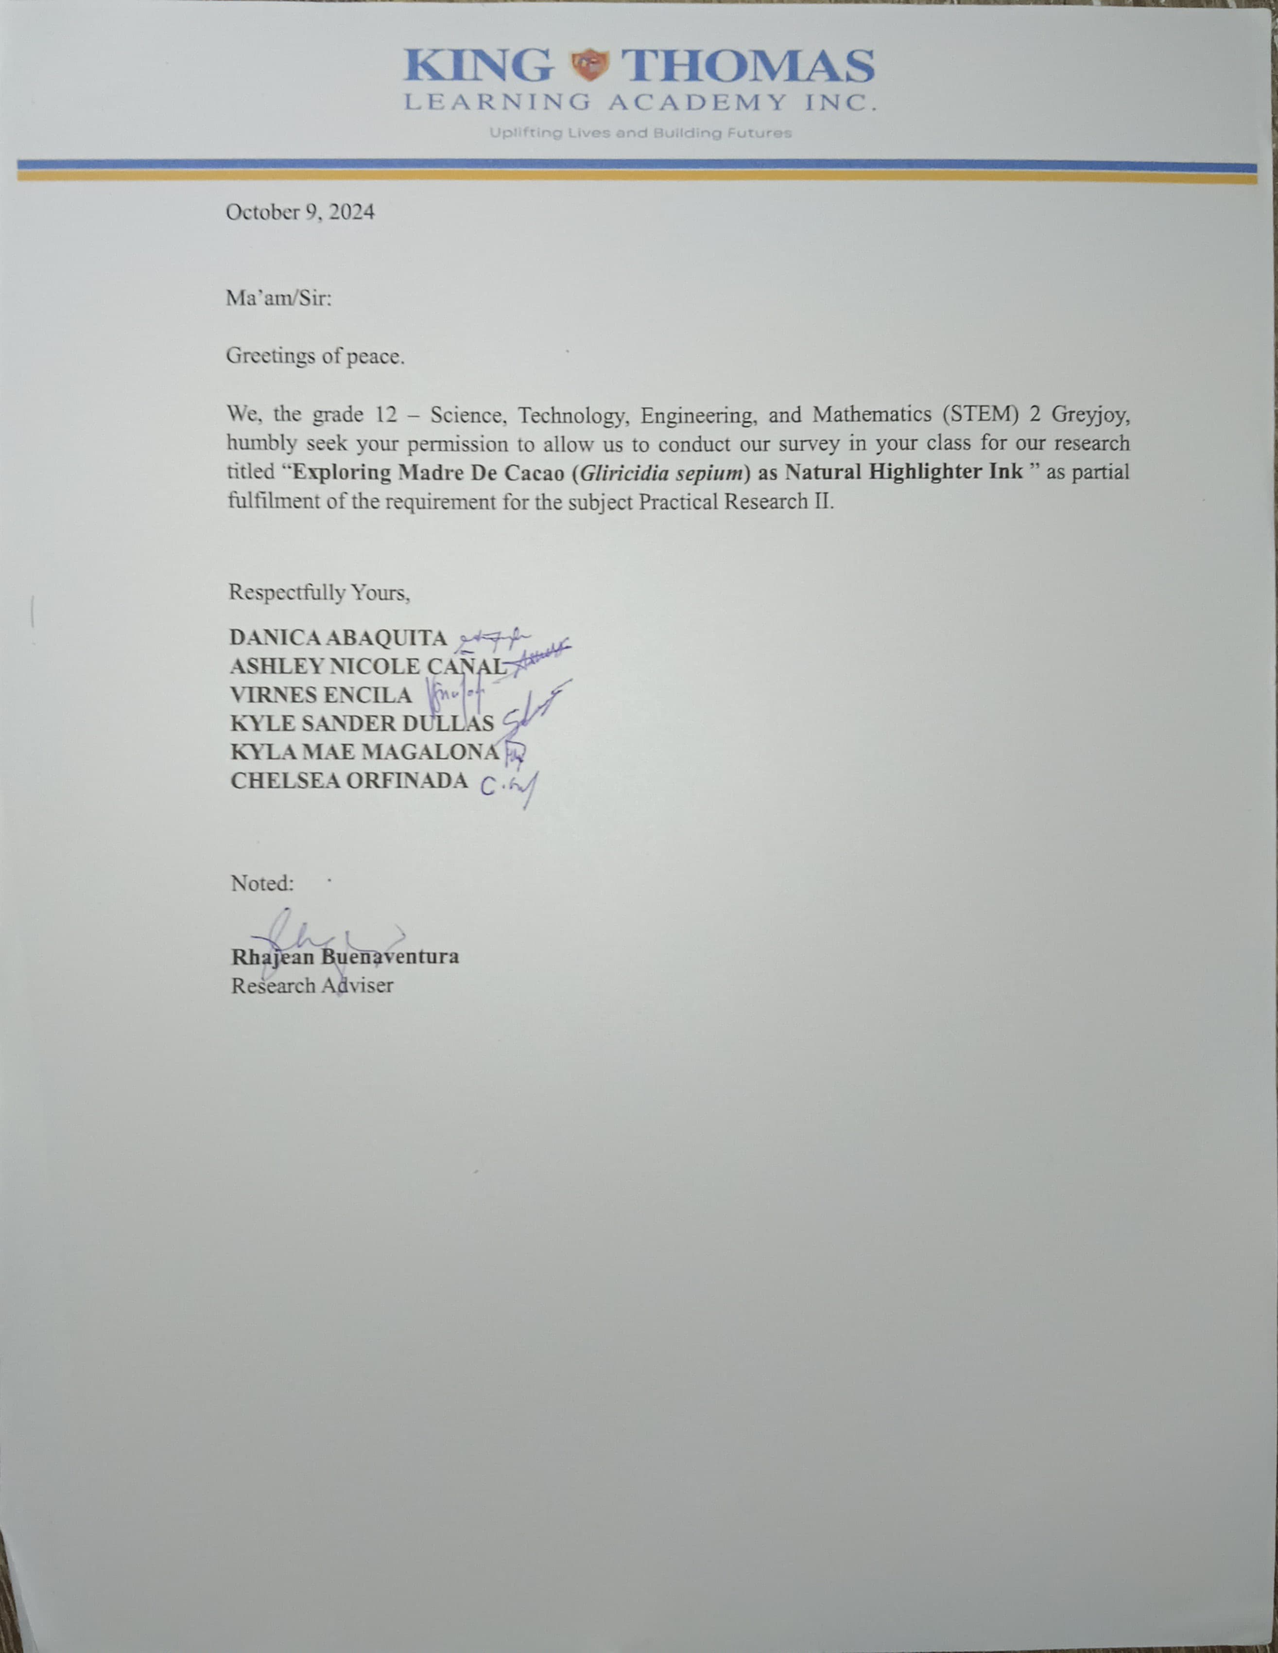

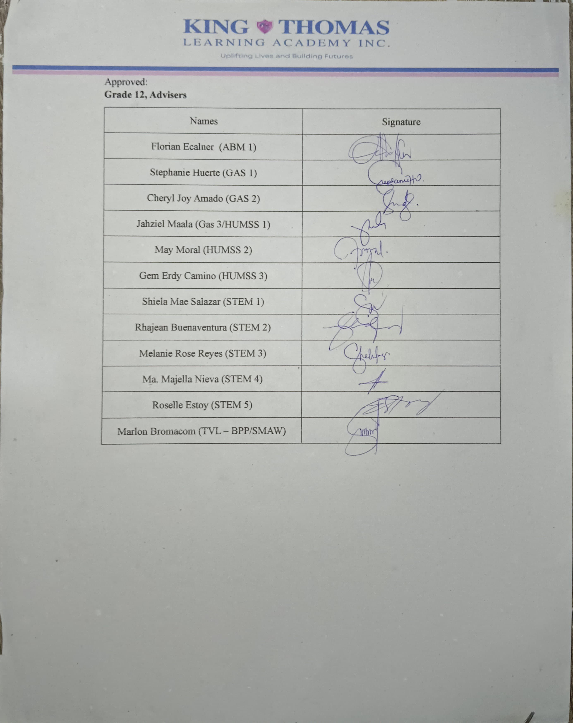

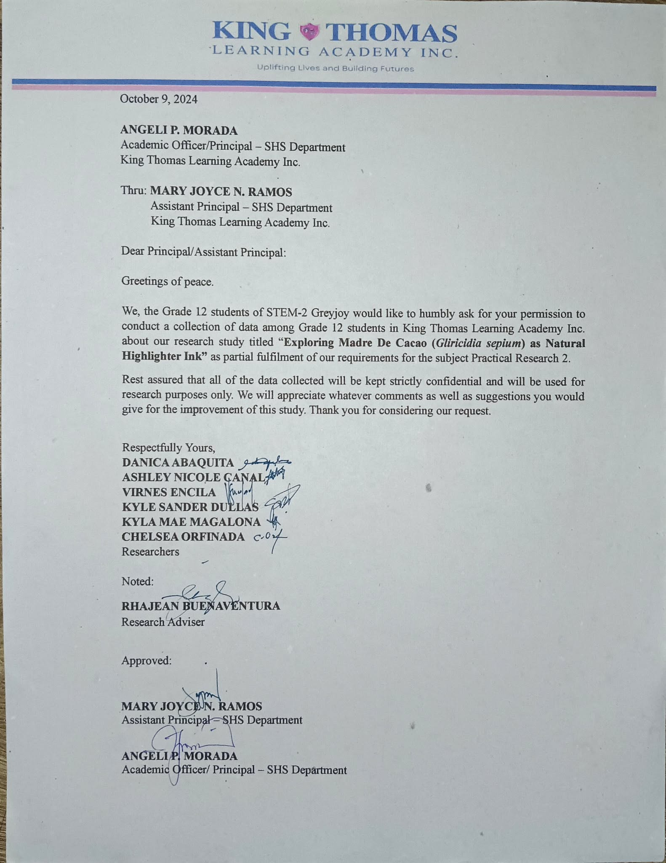

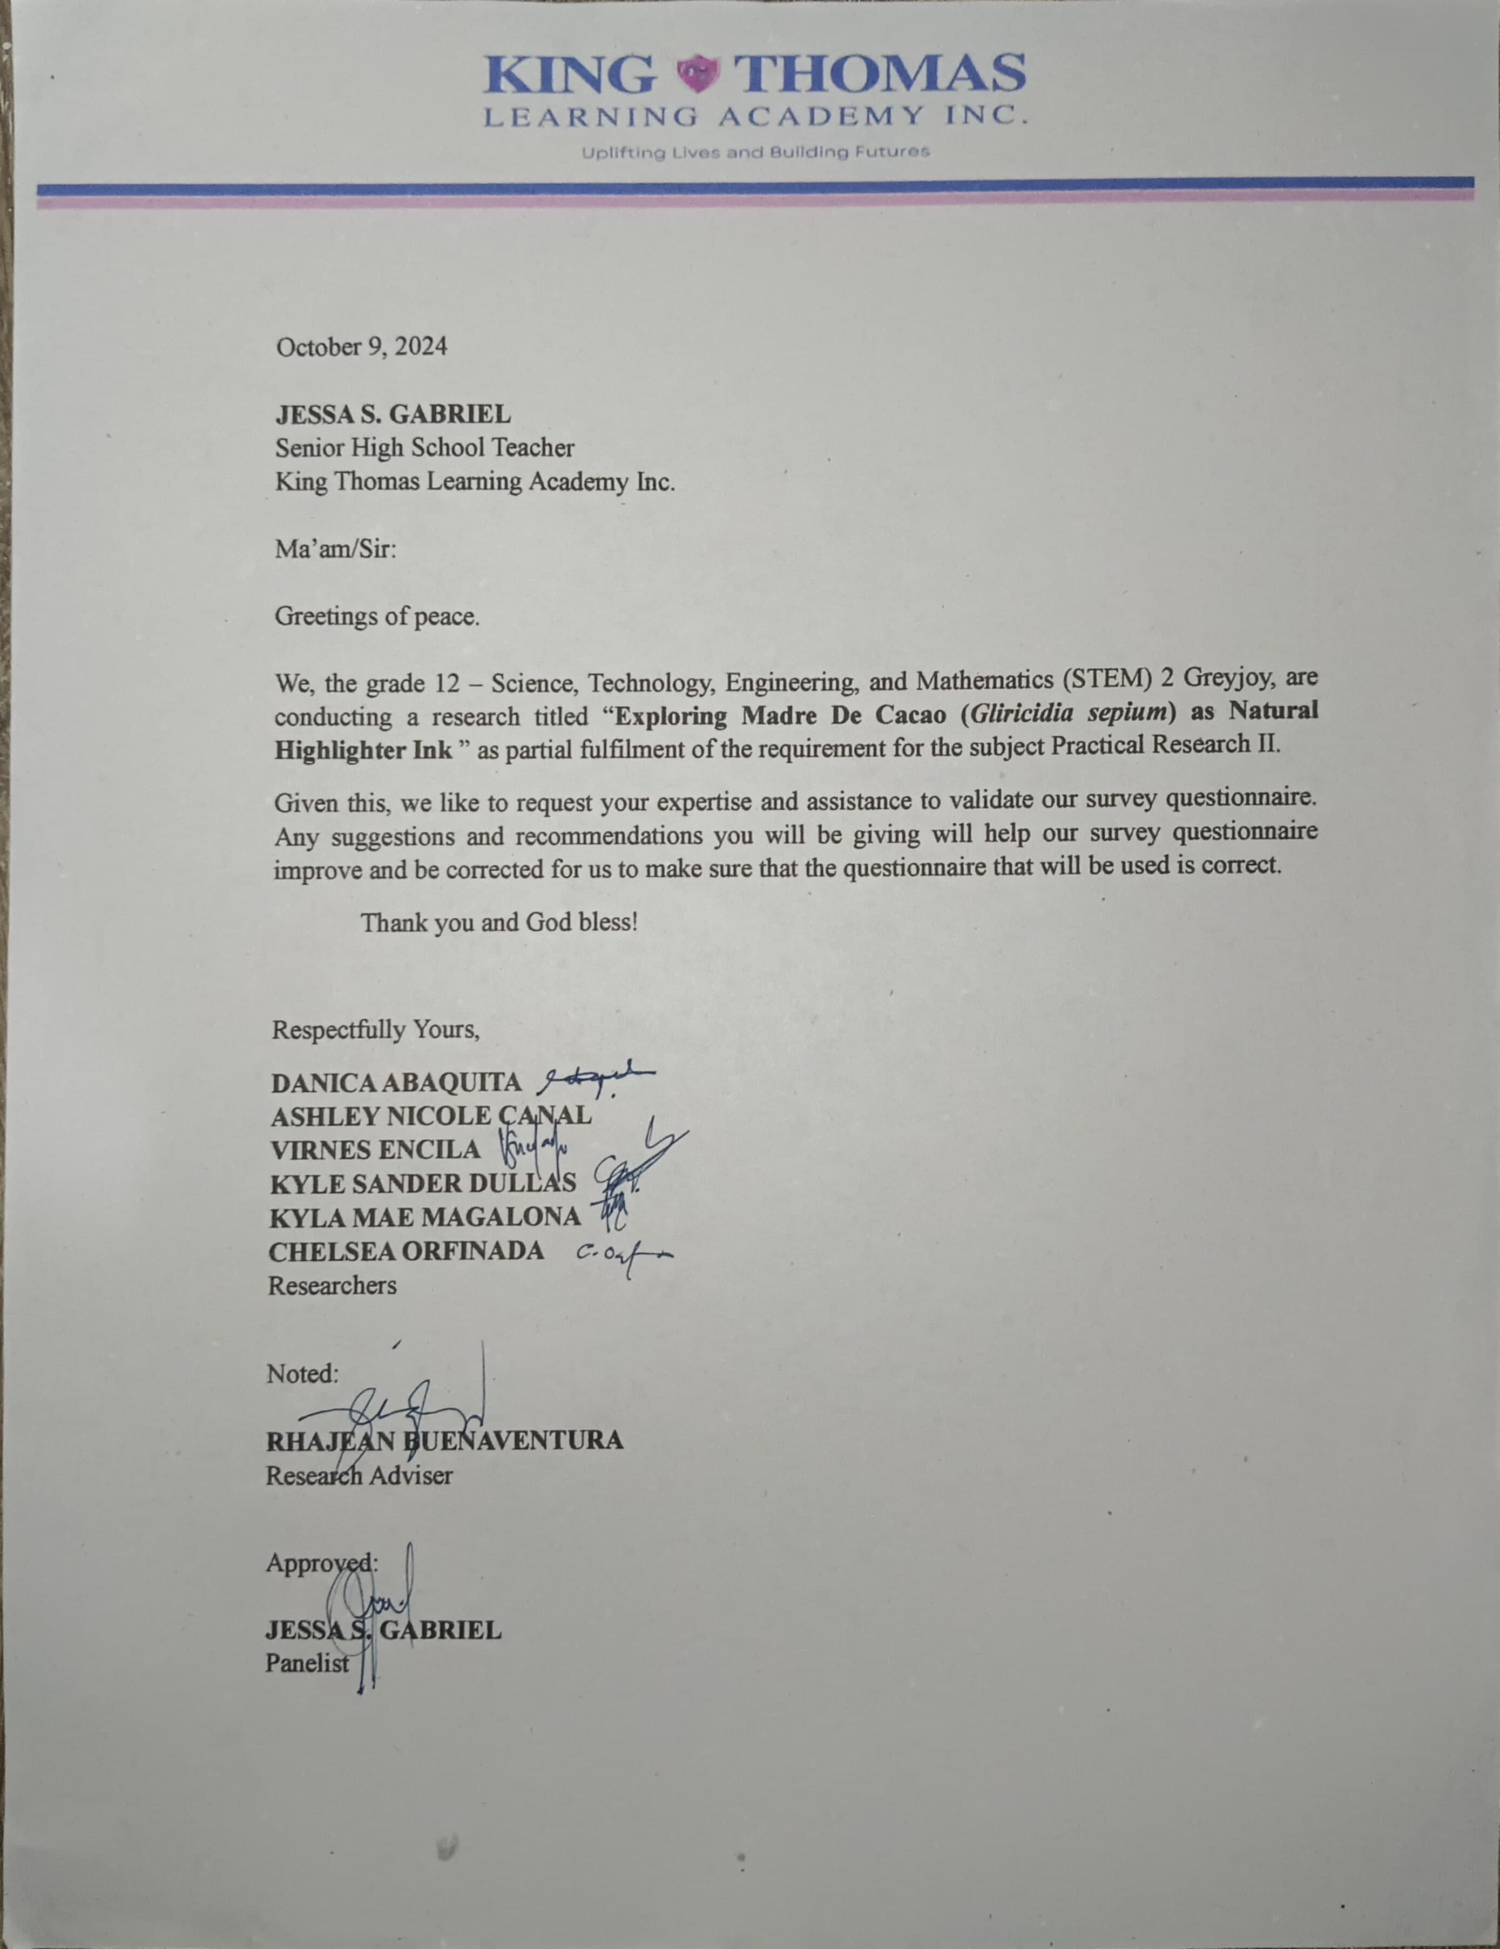

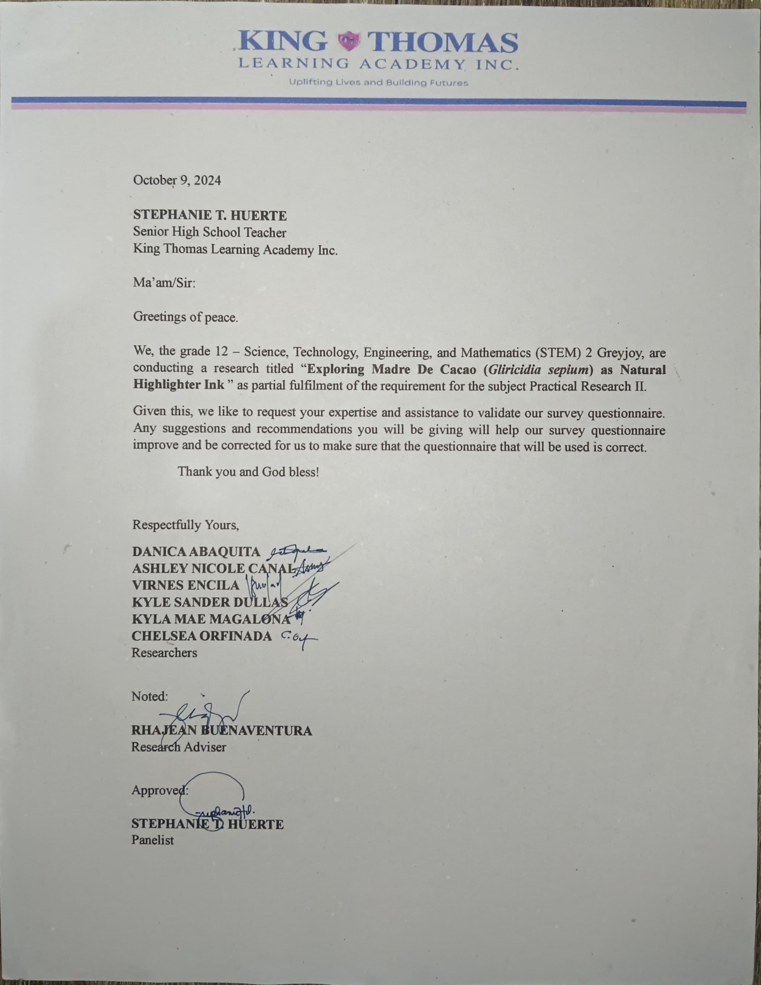

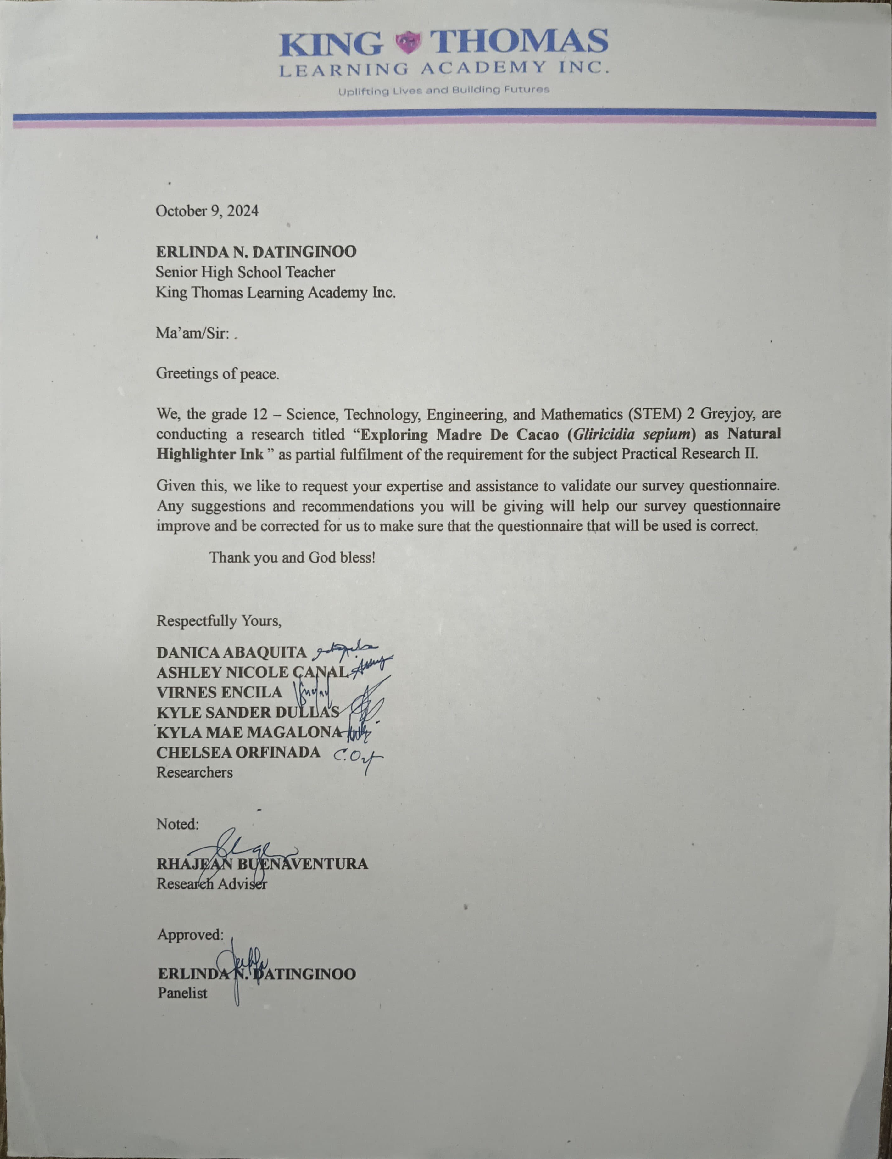

**APPENDIX C**

**SAMPLE QUESTIONNAIRE**

Department of Education

Region V

King Thomas Learning Academy Inc.

Malubago, Sipocot, Camarines Sur

**EXPLORING MADRE DE CACAO (*Gliricidia sepium*) AS NATURAL HIGHLIGHTER INK**

**QUESTIONNAIRE**

Dear respondent,

The researchers value your privacy and we will not share any of your personal information or individual responses with anyone. We will use the data you provide for research purposes only.

Respectfully yours,

Researchers

Name (optional): Date:

**Direction:** Please complete the questionnaire as completely and honestly as possible by checking (/) the appropriate boxes relating to your answer. We will handle your responses with the utmost care and discretion.

Legend: 4 – Strongly Agree

3 – Agree

2 – Disagree

1 – Strongly Disagree

**SOP 1. What is the level of effectiveness of Madre De Cacao among different concentrations in terms of color, opacity and smear-proof.**

|  |  |  |  |  |  |
| --- | --- | --- | --- | --- | --- |
| **25 g of Madre De Cacao** | | | | | |
| **Color** | Characteristics | 4 | 3 | 2 | 1 |
| The highlighter ink has a vibrant color. |  |  |  |  |
| The highlighter ink achieved intense color. |  |  |  |  |
| The highlighter ink is eye-catching. |  |  |  |  |
| The highlighter ink color creates visually striking contrast with the surrounding text. |  |  |  |  |
| The highlighter inks lacks vibrancy. |  |  |  |  |
| The highlighter ink color is dull and unappealing. |  |  |  |  |
| The ink color makes the text difficult to read. |  |  |  |  |
| The highlighter ink is light colored. |  |  |  |  |
| The highlighter ink is pale and muted. |  |  |  |  |
| The highlighter ink is painful to look at. |  |  |  |  |
| **Opacity** | When I use it in highlighting the text is still visible. |  |  |  |  |
| The highlighter ink is too transparent to effectively highlight text. |  |  |  |  |
| When I use it in highlighting the text is still readable. |  |  |  |  |
| The highlighter ink partially covers the underlying text, making it difficult to read. |  |  |  |  |
| The highlighter ink does not cover the text. |  |  |  |  |
| The highlighter ink is opaque and completely covers the underlying text. |  |  |  |  |
| The highlighter ink does not cover the text. |  |  |  |  |
| The highlighter ink does not obscure the text behind. |  |  |  |  |
| The highlighter ink allows visibility of the text underneath. |  |  |  |  |
| The highlighter ink completely covers the underlying text, making it completely illegible. |  |  |  |  |
| **Smear-proof** | The highlighter ink smears significantly when touched or rubbed shortly after application. |  |  |  |  |
| The highlighter ink does not smudge. |  |  |  |  |
| After applying the highlighter, it does not spread when touched. |  |  |  |  |
| The highlighter ink smear when highlighted over printed text. |  |  |  |  |
| The highlighter bleed through when used. |  |  |  |  |
| The highlighter ink adheres to the paper. |  |  |  |  |
| The highlighter ink does not dries quickly enough to prevent smearing when applied to paper. |  |  |  |  |
| The highlighter ink smudges easily. |  |  |  |  |
| The highlighter ink resist smearing. |  |  |  |  |
| The highlighter does not bleed through when used. |  |  |  |  |

|  |  |  |  |  |  |
| --- | --- | --- | --- | --- | --- |
| **50 g of Madre De Cacao** | | | | | |
| **Color** | **Characteristics** | **4** | **3** | **2** | **1** |
| The highlighter ink has a vibrant color. |  |  |  |  |
| The highlighter ink achieved intense color. |  |  |  |  |
| The highlighter ink is eye-catching. |  |  |  |  |
| The highlighter ink color creates visually striking contrast with the surrounding text. |  |  |  |  |
| The highlighter inks lacks vibrancy. |  |  |  |  |
| The highlighter ink color is dull and unappealing. |  |  |  |  |
| The ink color makes the text difficult to read. |  |  |  |  |
| The highlighter ink is light colored. |  |  |  |  |
| The highlighter ink is pale and muted. |  |  |  |  |
| The highlighter ink is painful to look at. |  |  |  |  |
| **Opacity** | When I use it in highlighting the text is still visible. |  |  |  |  |
| The highlighter ink is too transparent to effectively highlight text. |  |  |  |  |
| When I use it in highlighting the text is still readable. |  |  |  |  |
| The highlighter ink partially covers the underlying text, making it difficult to read. |  |  |  |  |
| The highlighter ink does not cover the text. |  |  |  |  |
| The highlighter ink is opaque and completely covers the underlying text. |  |  |  |  |
| The highlighter ink does not cover the text. |  |  |  |  |
| The highlighter ink does not obscure the text behind. |  |  |  |  |
| The highlighter ink allows visibility of the text underneath. |  |  |  |  |
| The highlighter ink completely covers the underlying text, making it completely illegible. |  |  |  |  |
| **Smear-proof** | The highlighter ink smears significantly when touched or rubbed shortly after application. |  |  |  |  |
| The highlighter ink does not smudge. |  |  |  |  |
| After applying the highlighter, it does not spread when touched. |  |  |  |  |
| The highlighter ink smear when highlighted over printed text. |  |  |  |  |
| The highlighter bleed through when used. |  |  |  |  |
| The highlighter ink adheres to the paper. |  |  |  |  |
| The highlighter ink does not dries quickly enough to prevent smearing when applied to paper. |  |  |  |  |
| The highlighter ink smudges easily. |  |  |  |  |
| The highlighter ink resist smearing. |  |  |  |  |
| The highlighter does not bleed through when used. |  |  |  |  |

|  |  |  |  |  |  |
| --- | --- | --- | --- | --- | --- |
| **75 g of Madre De Cacao** | | | | | |
| **Color** | **Characteristics** | **4** | **3** | **2** | **1** |
| The highlighter ink has a vibrant color. |  |  |  |  |
| The highlighter ink achieved intense color. |  |  |  |  |
| The highlighter ink is eye catching. |  |  |  |  |
| The highlighter ink color creates visually striking contrast with the surrounding text. |  |  |  |  |
| The highlighter inks lacks vibrancy. |  |  |  |  |
| The highlighter ink color is dull and unappealing. |  |  |  |  |
| The ink color makes the text difficult to read. |  |  |  |  |
| The highlighter ink is light colored. |  |  |  |  |
| The highlighter ink is pale and muted. |  |  |  |  |
| The highlighter ink is painful to look at. |  |  |  |  |
| **Opacity** | When I used in highlighting the text is still visible. |  |  |  |  |
| The highlighter ink is too transparent to effectively highlight text. |  |  |  |  |
| When I used in highlighting the text is still readable. |  |  |  |  |
| The highlighter ink partially covers the underlying text, making it difficult to read. |  |  |  |  |
| The highlighter ink does not cover the text. |  |  |  |  |
| The highlighter ink is opaque and completely covers the underlying text. |  |  |  |  |
| The highlighter ink does not cover the text. |  |  |  |  |
| The highlighter ink does not obscure the text behind. |  |  |  |  |
| The highlighter ink allows visibility of the text underneath. |  |  |  |  |
| The highlighter ink completely covers the underlying text, making it completely illegible. |  |  |  |  |
| **Smear-proof** | The highlighter ink smears significantly when touched or rubbed shortly after application. |  |  |  |  |
| The highlighter ink does not smudge. |  |  |  |  |
| After applying the highlighter, it does not spread when touched. |  |  |  |  |
| The highlighter ink smear when highlighted over printed text. |  |  |  |  |
| The highlighter bleed through when used. |  |  |  |  |
| The highlighter ink adheres to the paper. |  |  |  |  |
| The highlighter ink does not dries quickly enough to prevent smearing when applied to paper. |  |  |  |  |
| The highlighter ink smudges easily. |  |  |  |  |
| The highlighter ink resist smearing. |  |  |  |  |
| The highlighter does not bleed through when used. |  |  |  |  |

**SOP 2. What is the level of acceptability of Madre De Cacao as highlighter ink in terms of odor and packaging.**

|  |  |  |  |  |  |
| --- | --- | --- | --- | --- | --- |
| **25 g of Madre De Cacao** | | | | | |
| **Odor** | **Characteristics** | **4** | **3** | **2** | **1** |
| The highlighter has a refreshing scent. |  |  |  |  |
| The highlighter’s odor is fresh and subtle. |  |  |  |  |
| The highlighter smells good and is not overpowering. |  |  |  |  |
| The highlighter has a soothing smell. |  |  |  |  |
| The highlighter’s smell is light and pleasant. |  |  |  |  |
| The highlighter has an irritating scent. |  |  |  |  |
| The highlighter’s odor is unpleasant. |  |  |  |  |
| The highlighter has an overpowering smell. |  |  |  |  |
| The highlighter has a harsh smell. |  |  |  |  |
| The highlighter’s smell is distracting. |  |  |  |  |
| **Packaging** | The highlighter’s packaging has simple and minimalist design. |  |  |  |  |
| The highlighter’s packaging is secure and leak-proof. |  |  |  |  |
| The highlighter’s package is easy to handle and to use. |  |  |  |  |
| The highlighter’s packaging is transparent and easy to monitor ink level. |  |  |  |  |
| The highlighter’s packaging is good for refilling. |  |  |  |  |
| The highlighter’s packaging looks vulnerable to cracking or breaking. |  |  |  |  |
| The highlighter’s packaging is potential in leakage if not sealed properly. |  |  |  |  |
| The highlighter’s packaging has small cap that could be easily lost. |  |  |  |  |
| The highlighter’s packaging is to plain and lack in design. |  |  |  |  |
| The highlighter’s packaging is unattractive and unappealing. |  |  |  |  |

|  |  |  |  |  |  |
| --- | --- | --- | --- | --- | --- |
| **50 g of Madre De Cacao** | | | | | |
| **Odor** | **Characteristics** | **4** | **3** | **2** | **1** |
| The highlighter has a refreshing scent. |  |  |  |  |
| The highlighter’s odor is fresh and subtle. |  |  |  |  |
| The highlighter smells good and is not overpowering. |  |  |  |  |
| The highlighter has a soothing smell. |  |  |  |  |
| The highlighter’s smell is light and pleasant. |  |  |  |  |
| The highlighter has an irritating scent. |  |  |  |  |
| The highlighter’s odor is unpleasant. |  |  |  |  |
| The highlighter has an overpowering smell. |  |  |  |  |
| The highlighter has a harsh smell. |  |  |  |  |
| The highlighter’s smell is distracting. |  |  |  |  |
| **Packaging** | The highlighter’s packaging has simple and minimalist design. |  |  |  |  |
| The highlighter’s packaging is secure and leak-proof. |  |  |  |  |
| The highlighter’s package is easy to handle and to use. |  |  |  |  |
| The highlighter’s packaging is transparent and easy to monitor ink level. |  |  |  |  |
| The highlighter’s packaging is good for refilling. |  |  |  |  |
| The highlighter’s packaging looks vulnerable to cracking or breaking. |  |  |  |  |
| The highlighter’s packaging is potential in leakage if not sealed properly. |  |  |  |  |
| The highlighter’s packaging has small cap that could be easily lost. |  |  |  |  |
| The highlighter’s packaging is to plain and lack in design. |  |  |  |  |
| The highlighter’s packaging is unattractive and unappealing. |  |  |  |  |

|  |  |  |  |  |  |
| --- | --- | --- | --- | --- | --- |
| **75 g of Madre De Cacao** | | | | | |
| **Odor** | **Characteristics** | **4** | **3** | **2** | **1** |
| The highlighter has a refreshing scent. |  |  |  |  |
| The highlighter’s odor is fresh and subtle. |  |  |  |  |
| The highlighter smells good and is not overpowering. |  |  |  |  |
| The highlighter has a soothing smell. |  |  |  |  |
| The highlighter’s smell is light and pleasant. |  |  |  |  |
| The highlighter has an irritating scent. |  |  |  |  |
| The highlighter’s odor is unpleasant. |  |  |  |  |
| The highlighter has an overpowering smell. |  |  |  |  |
| The highlighter has a harsh smell. |  |  |  |  |
| The highlighter’s smell is distracting. |  |  |  |  |
| **Packaging** | The highlighter’s packaging has simple and minimalist design. |  |  |  |  |
| The highlighter’s packaging is secure and leak-proof. |  |  |  |  |
| The highlighter’s package is easy to handle and to use. |  |  |  |  |
| The highlighter’s packaging is transparent and easy to monitor ink level. |  |  |  |  |
| The highlighter’s packaging is good for refilling. |  |  |  |  |
| The highlighter’s packaging looks vulnerable to cracking or breaking. |  |  |  |  |
| The highlighter’s packaging is potential in leakage if not sealed properly. |  |  |  |  |
| The highlighter’s packaging has small cap that could be easily lost. |  |  |  |  |
| The highlighter’s packaging is to plain and lack in design. |  |  |  |  |
| The highlighter’s packaging is unattractive and unappealing. |  |  |  |  |

**Observation sheet**

Legends:

|  |  |
| --- | --- |
| **Numerical rating** | **Verbal interpretation** |
| 4 | Highly Acceptable |
| 3 | Acceptable |
| 2 | Not Acceptable |
| 1 | Not Highly Acceptable |

|  |  |  |  |  |  |
| --- | --- | --- | --- | --- | --- |
|  | Days of observation | 4 | 3 | 2 | 1 |
| 25% concentration | Day 1 |  |  |  |  |
| Day 2 |  |  |  |  |
| Day 3 |  |  |  |  |
| Day 4 |  |  |  |  |
| Day 5 |  |  |  |  |
| Day 6 |  |  |  |  |
| Day 7 |  |  |  |  |
| Day 8 |  |  |  |  |
| Day 9 |  |  |  |  |
| Day 10 |  |  |  |  |
| 50% concentration | Days of observation | 4 | 3 | 2 | 1 |
| Day 1 |  |  |  |  |
| Day 2 |  |  |  |  |
| Day 3 |  |  |  |  |
| Day 4 |  |  |  |  |
| Day 5 |  |  |  |  |
| Day 6 |  |  |  |  |
| Day 7 |  |  |  |  |
| Day 8 |  |  |  |  |
| Day 9 |  |  |  |  |
| Day 10 |  |  |  |  |
| 75% concentration | Days of Observation | 4 | 3 | 2 | 1 |
| Day 1 |  |  |  |  |
| Day 2 |  |  |  |  |
| Day 3 |  |  |  |  |
| Day 4 |  |  |  |  |
| Day 5 |  |  |  |  |
| Day 6 |  |  |  |  |
| Day 7 |  |  |  |  |
| Day 8 |  |  |  |  |
| Day 9 |  |  |  |  |
| Day 10 |  |  |  |  |

**APPENDIX D**

**STATISTICAL COMPUTATIONS**

**SOP 1**

|  |  |  |  |  |
| --- | --- | --- | --- | --- |
| *Groups* | *Count* | *Sum* | *Average* | *Variance* |
| Column 1 | 2 | 2.94 | 1.47 | 2.9768 |
| Column 2 | 2 | 3.23 | 1.615 | 2.48645 |
| Column 3 | 2 | 3.5 | 1.75 | 2 |

**SOP 2**

|  |  |  |  |  |
| --- | --- | --- | --- | --- |
| *Groups* | *Count* | *Sum* | *Average* | *Variance* |
| Column 1 | 2 | 2.8 | 1.4 | 2.645 |
| Column 2 | 2 | 3.14 | 1.57 | 2.2898 |
| Column 3 | 2 | 3.38 | 1.69 | 1.7672 |

**SOP 3**

|  |  |  |  |  |  |  |
| --- | --- | --- | --- | --- | --- | --- |
| ANOVA |  |  |  |  |  |  |
| *Source of Variation* | *SS* | *df* | *MS* | *F* | *P-value* | *F crit* |
| Between Groups | 0.078433 | 2 | 0.039217 | 0.015764 | 0.984441 | 9.552094 |
| Within Groups | 7.46325 | 3 | 2.48775 |  |  |  |
|  |  |  |  |  |  |  |
| Total | 7.541683 | 5 |  |  |  |  |

|  |  |  |  |  |  |  |
| --- | --- | --- | --- | --- | --- | --- |
| *Source of Variation* | *SS* | *df* | *MS* | *F* | *P-value* | *F crit* |
| Between Groups | 0.084933 | 2 | 0.042467 | 0.019009 | 0.981287 | 9.552094 |
| Within Groups | 6.702 | 3 | 2.234 |  |  |  |
|  |  |  |  |  |  |  |
| Total | 6.786933 | 5 |  |  |  |  |

**APPENDIX E**

**DOCUMENTATION**

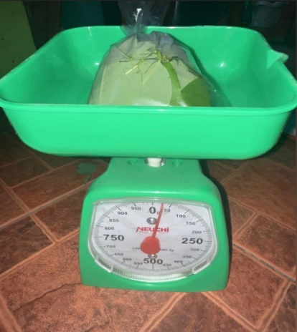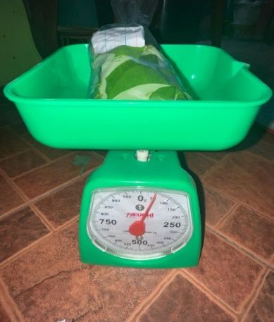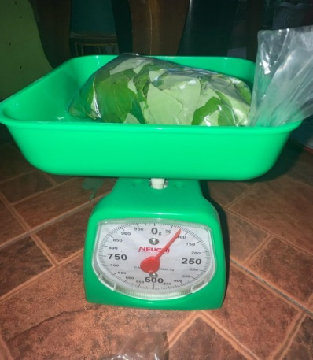

50 grams of Madre De Cacao

(50% concentration).

75 grams of Madre De Cacao

(75% concentration).

25 grams of Madre De Cacao

(25% concentration).

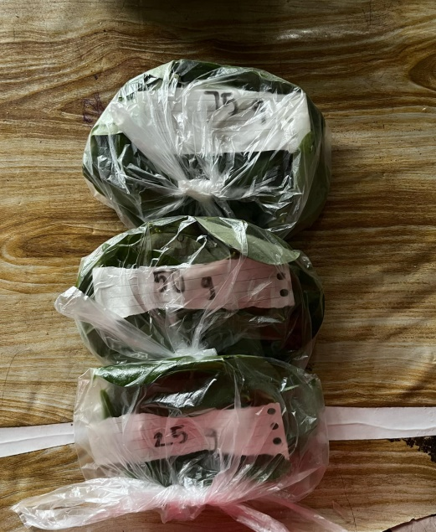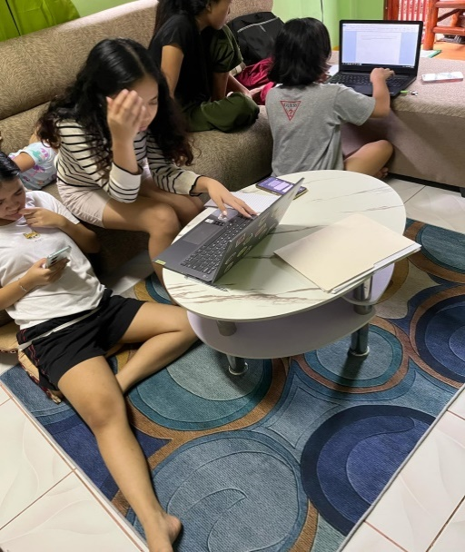

Madre De Cacao leaves (25 g, 50, 75 g)

Researchers working on with the papers.

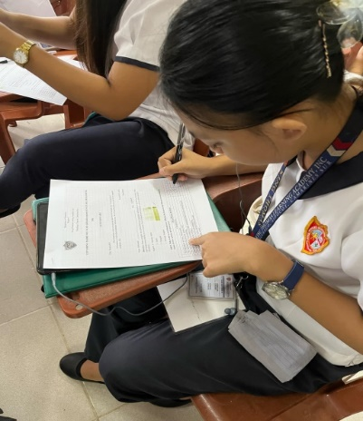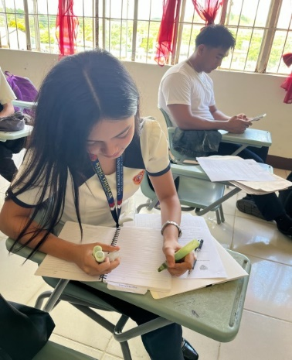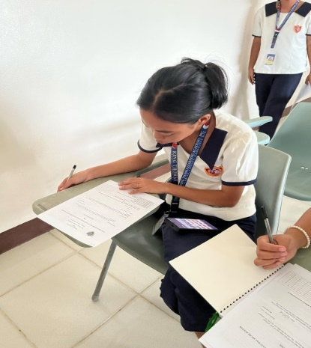

Respondents deep in a sense of concentration and commitment answering the survey questionnaires.

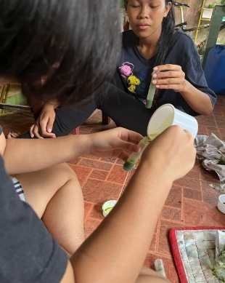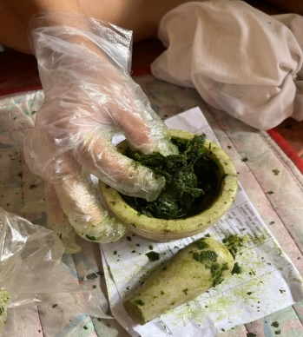

Researchers doing their experimental research. First by grinding the Madre De Cacao leaves then get the extract and put it into the designated container.

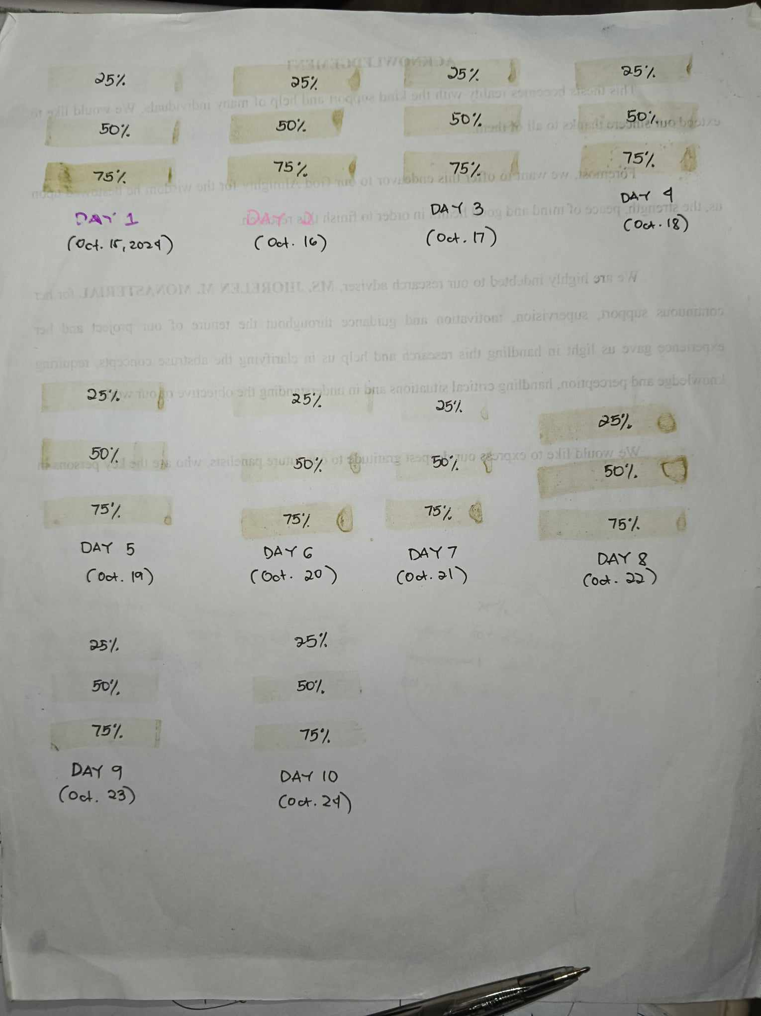

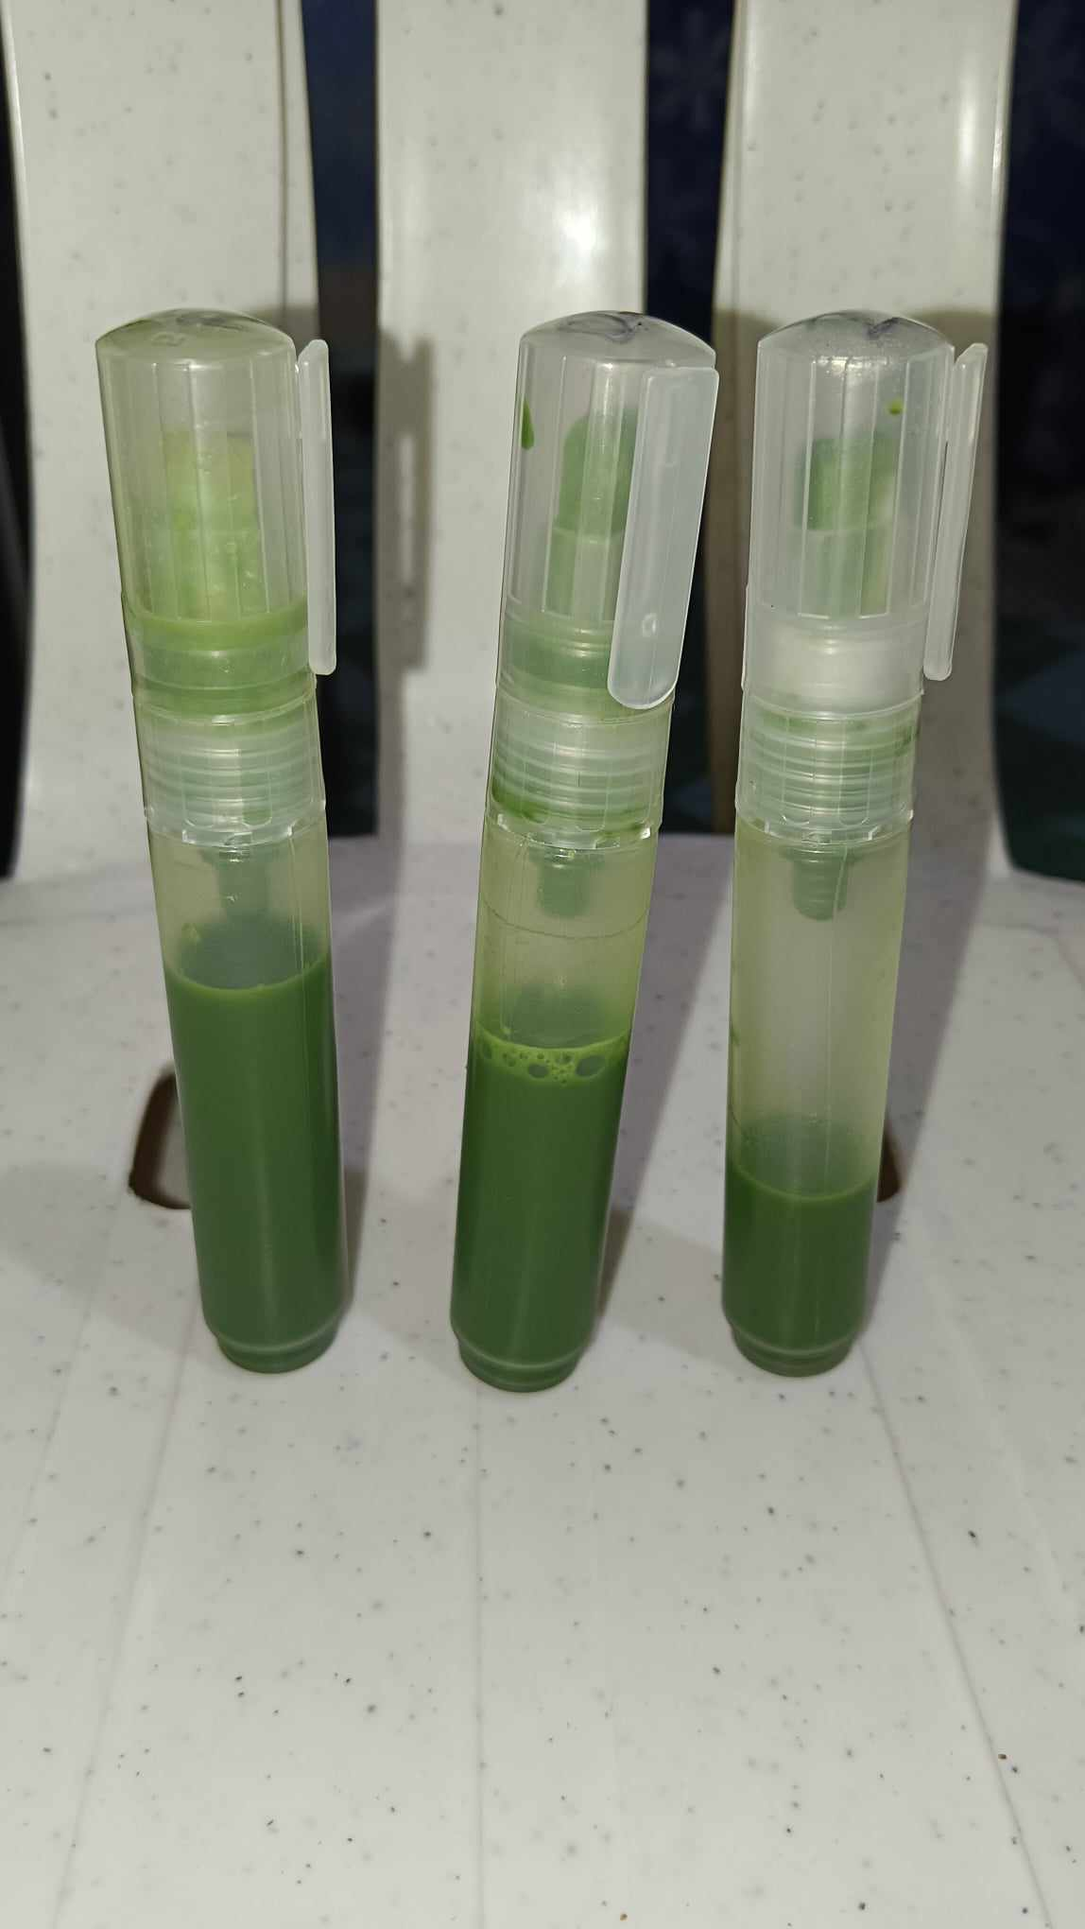

Finished product.

Day 1 up to day 10 observations.

**APPENDIX F**

**CURRICULUM VITAE**

**DANICA E. ABAQUITA**

North Villazar, Sipocot, Camarines Sur.

Contact No.: 09308093621

Email: danicaabaquita4@gmail.com

Facebook: Danica Abaquita

|  |
| --- |
| **OBJECTIVE:**  The main objective of research for me as a student is to solve problems by gathering and evaluating information. Research plays a significant role which enhances critical thinking skills in a way of gaining new knowledge. |
| **PERSONAL BACKGROUND:**  **Date of Birth: March 19, 2007**  **Age: 17**  **Religion: Roman Catholic**  **Civil Status: Single**  **Gender: Female**  **Citizenship: Filipino**  **Languages: Tagalog, Bikol, and English**  **Height: 5’1 ½**  **Weight: 45**  **Hair Color: Black**  **Father’s Name: Danilo P. Abaquita**  **Mother’s Name: Myrna E. Abaquita** |
| **EDUCATIONAL ATTAINMENT:**  **Secondary: KING THOMAS LEARNING ACADEMY INC.**  **MALUBAGO, SIPOCOT, CAMARINES SUR.**  **2023**  **Elementary: NORTH VILLAZAR ELEMENTARY SCHOOL**  **NORTH VILLAZAR, SIPOCOT, CAMARINES SUR.**  **2019** |
| **STRENGTH AND QUALIFICATION:**   * **Time management** * **Organize** * **Multitasking** * **Attention to Detail** |
| **RESEARCH UNDERTAKEN:**  **Feminism Approach Criticism: John Musker and Ron Clements “Moana”** |
| **CHARACTER REFERENCES:**  **Rhajean Reyes Buenaventura**  **0999-446-9069** |



**ASHLEY NICOLE O.CAÑAL**

South Centro, Sipocot, Camarines Sur 4408

Contact No.: 09383394453

Email: ashleycanal094@gmail.com

Facebook: Ashley Nicole Oseo Cañal

|  |
| --- |
| **OBJECTIVE:**  The main objective of research for me as a student is it contribute to us, as a student to grow academically. It develop skills like analyzing, interpreting data, communication, and more. It also gain more understanding on every chosen subject. |
| **PERSONAL BACKGROUND:**  **Date of Birth: November 15, 2006**  **Age: 18**  **Religion: Roman Catholic**  **Civil Status: Single**  **Gender: Female**  **Citizenship: Filipino**  **Languages: Filipino, English, Bikol**  **Height: 149 cm**  **Weight: 45. 4 kg**  **Hair Color: Black**  **Father’s Name: Emmanuel N. Cañal**  **Mother’s Name: Marissa O. Cañal** |
| **EDUCATIONAL ATTAINMENT:**  **Secondary: KING THOMAS LEARNING ACADEMY INC.**  **MALUBAGO, SIPOCOT CAMARINES SUR**  **2023**  **Elementary: SIPOCOT SOUTH CENTRAL SCHOOL**  **SOUTH CENTRO, SIPOCOT CAMARINES SUR**  **2019** |
| **STRENGTH AND QUALIFICATION:**   * **Time management** * **Organize** * **Multitasking** |
| **RESEARCH UNDERTAKEN:**  **Feminism Approach Criticism: John Musker and Ron Clements “Moana”** |
| **CHARACTER REFERENCES:**  **Rhajean Reyes Buenaventura**  **0999-446-9069** |

**KYLE SANDER C. DULLAS**

654 Deguzman St. Sipocot Camarines Sur 4408

Contact No.: 09514275678

Email: kylesdullas@gmail.com

Facebook: Kyle Sander Dullas

|  |
| --- |
| **OBJECTIVE:**  A systematic process of seeking out answers to questions or problems. |
| **PERSONAL BACKGROUND:**  **Date of Birth: October 16, 2006**  **Age: 18**  **Religion: Roman Catholic**  **Civil Status: Single**  **Gender: Male**  **Citizenship: Filipino**  **Languages: Tagalog, Bikol, and English**  **Height: 5’7**  **Weight: 62 lbs**  **Hair Color: Black**  **Father’s Name: Hermogenes A. Dullas**  **Mother’s Name: Helen C. Dullas** |
| **EDUCATIONAL ATTAINMENT:**  **Secondary: KING THOMAS LEARNING ACADEMY INC.**  **MALUBAGO, SIPOCOT CAMARINES SUR**  **2023**  **Elementary: SERRANZ LEARNING CENTER INC**  **CASNIMAN ST. SIPOCOT CAMARINES SUR**  **2019** |
| **STRENGTH AND QUALIFICATION:**   * **Creative, flexible, communication, leadership** * **Education, hard skills, soft skills, experience** |
| **RESEARCH UNDERTAKEN:**  **Analyzing The Effects Of Strand Discrimination In Grade 11 Students Of King Thomas Learning Academy Inc.** |
| **CHARACTER REFERENCES:**  **Rhajean Reyes Buenaventura**  **0999-446-9069** |



**VIRNES JIRAH G. ENCILA**

Happy Homes, Malubago, Sipocot Camarines Sur 4408

Contact No.: 09813070849

Email: virnesgarcia@gmail.com

Facebook: Virnes Encila

|  |
| --- |
| **OBJECTIVE:**  The main objective of research for me as a student is it contribute more to our knowledge and it generate new insights being a student. It also enhance my understanding to a certain topic and deepen knowledge in other perspectives. |
| **PERSONAL BACKGROUND:**  **Date of Birth: June 29, 2007**  **Age: 17**  **Religion: Born Again Christian**  **Civil Status: Single**  **Gender: Female**  **Citizenship: Filipino**  **Languages: Filipino, English ,Bikol**  **Height: 5’0**  **Weight: 47**  **Hair Color: Black**  **Father’s Name: Ruben G. Encila**  **Mother’s Name: Mila G. Encila** |
| **EDUCATIONAL ATTAINMENT:**  **Secondary: JAIME MACATANGAY SR. NATIONAL HIGH SCHOOL**  **CAIMA, SIPOCOT, CAMARINES SUR**  **2023**  **Elementary: CAIMA ELEMENTARY SCHOOL**  **CAIMA, SIPOCOT, CAMARINES SUR**  **2019** |
| **STRENGTH AND QUALIFICATION:**   * **Dedication** * **Self- Motivated** * **Detail- oriented** |
| **RESEARCH UNDERTAKEN:**  **Cultural Approach Criticism: Binibining Mia’s “I Love You Since 1892”** |
| **CHARACTER REFERENCES:**  **Rhajean Reyes Buenaventura**  **0999-446-9069** |

**KYLA MAE T. M AGALONA**

Zone 2. San Pedro Cabusao Camarines Sur

Contact No.: 09203264775

Email: kylamaemagalona@gmail.com

Facebook: Kyla Mae Magalona

|  |
| --- |
| **OBJECTIVE:**  To learn, to think critically, and to contribute new knowledge. |
| **PERSONAL BACKGROUND:**  **Date of Birth: September 16, 2006**  **Age: 18**  **Religion: Roman Catholic**  **Civil Status: Single**  **Gender: Female**  **Citizenship: Filipino**  **Languages: Bikol, Tagalog, and English**  **Height: 5'1**  **Weight: 44**  **Hair Color: Black**  **Father’s Name: Rommel A. Magalona Sr.**  **Mother’s Name: Myriam T. Magalona** |
| **EDUCATIONAL ATTAINMENT:**  **Secondary: SIPOCOT NATIONAL HIGH SCHOOL**  **TARA, SIPOCOT, CAMARINES SUR.**  **2023**  **Elementary: SAN PEDRO ELEMENTARY SCHOOL**  **SAN PEDRO CABUSAO CAMARINES SUR**  **2019** |
| **STRENGTH AND QUALIFICATION:**   * **Resilience** * **Experience** |
| **RESEARCH UNDERTAKEN:**  **Feminism Critical Approach the man by Taylor swift songs** |
| **CHARACTER REFERENCES:**  **Rhajean Reyes Buenaventura**  **0999-446-9069** |

**CHELSEA B. ORFINADA**

San Pedro Cabusao Camarines Sur

Contact No.: 09516217220

Email: seac7367@gmail.com

Facebook: Chelsea Orfinada

|  |
| --- |
| **OBJECTIVE:**  As a student, the main objective of research for me is to gain a deeper understanding of a topic and learn new things. |
| **PERSONAL BACKGROUND:**  **Date of Birth: February 6, 2007**  **Age: 17**  **Religion: Roman Catholic**  **Civil Status: Single**  **Gender: Female**  **Citizenship: Filipino**  **Languages: Filipino, English, Bikol**  **Height: 4’11**  **Weight: 43**  **Hair Color: Black**  **Father’s Name: Richel B. Orfinada**  **Mother’s Name: Eva B. Orfinada** |
| **EDUCATIONAL ATTAINMENT:**  **Secondary: KING THOMAS LEARNING ACADEMY INC.**  **MALUBAGO, SIPOCOT CAMARINES SUR**  **2023**  **Elementary: SAN PEDRO ELEMENTARY SCHOOL**  **SAN PEDRO CABUSAO CAMARINES SUR**  **2019** |
| **STRENGTH AND QUALIFICATION:**   * **Ability to work under pressure and meet deadlines** * **Adaptable and quick to learn new skills** |
| **RESEARCH UNDERTAKEN:**  **Feminist Approach Criticism:John Musker and Ron Clement’s “Moana”**  **The Effect of Stress and Academic Validation to the Academic Performance of Grade 10 students in KTLA** |
| **CHARACTER REFERENCES:**  **Rhajean Reyes Buenaventura**  **0999-446-9069** |